**BANKING SYSTEM**

**TASK 1:**

**Database Design:**

1. CREATE DATABASE HMBank;

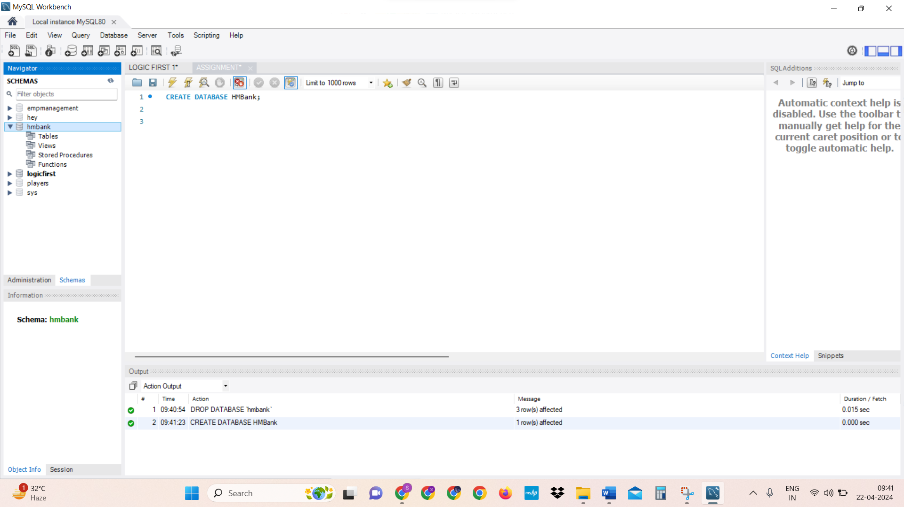

1. USE HMbank;

CREATE TABLE Customers (

customer_id INT PRIMARY KEY AUTO_INCREMENT,

first_name VARCHAR(50),

last_name VARCHAR(50),

DOB DATE,

email VARCHAR(100),

phone_number VARCHAR(20),

address VARCHAR(255)

);

CREATE TABLE Accounts (

account_id INT PRIMARY KEY AUTO_INCREMENT,

customer_id INT,

account_type VARCHAR(50),

balance DECIMAL(15, 2),

FOREIGN KEY (customer_id) REFERENCES Customers(customer_id)

);

CREATE TABLE Transactions (

transaction_id INT PRIMARY KEY AUTO_INCREMENT,

account_id INT,

transaction_type VARCHAR(50),

amount DECIMAL(15, 2),

transaction_date TIMESTAMP,

FOREIGN KEY (account_id) REFERENCES Accounts(account_id)

);

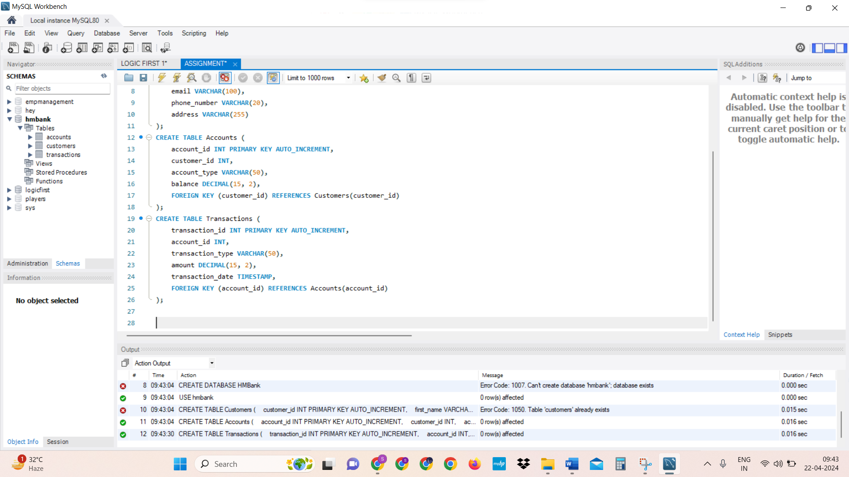

**One-to-Many Relationship between Customers and Accounts:**

Each customer (record in the Customers table) can have multiple accounts (records in the Accounts table).

This is represented by a one-to-many relationship, where one customer can be associated with multiple accounts, but each account is associated with only one customer.

In the database schema, the relationship is established by having a foreign key customer_id in the Accounts table referencing the primary key customer_id in the Customers table.

**One-to-Many Relationship between Accounts and Transactions:**

Each account (record in the Accounts table) can have multiple transactions (records in the Transactions table).

This is represented by a one-to-many relationship, where one account can have multiple transactions, but each transaction is associated with only one account.

In the database schema, the relationship is established by having a foreign key account_id in the Transactions table referencing the primary key account_id in the Accounts table.

-----< represents a one-to-many relationship.

The arrow points from the "one" side to the "many" side of the relationship.

Customers can have multiple accounts.

Accounts can have multiple transactions.

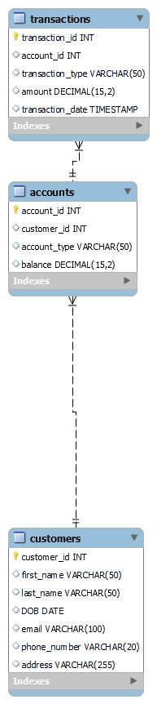

**TASK 2:**

**Select, Where, Between, AND, LIKE:**

1. INSERT INTO Customers (first_name, last_name, DOB, email, phone_number, address)

VALUES

('John', 'Doe', '1990-05-15', 'john.doe@example.com', '123-456-7890', '123 Main St'),

('Jane', 'Smith', '1985-10-20', 'jane.smith@example.com', '987-654-3210', '456 Elm St'),

('Michael', 'Johnson', '1978-03-12', 'michael.johnson@example.com', '555-123-4567', '789 Oak St'),

('Emily', 'Williams', '1995-07-08', 'emily.williams@example.com', '111-222-3333', '101 Pine St'),

('David', 'Brown', '1980-11-25', 'david.brown@example.com', '444-555-6666', '202 Maple St'),

('Sarah', 'Taylor', '1989-09-18', 'sarah.taylor@example.com', '777-888-9999', '303 Cedar St'),

('Matthew', 'Anderson', '1983-12-30', 'matthew.anderson@example.com', '333-222-1111', '404 Birch St'),

('Jessica', 'Martinez', '1992-02-14', 'jessica.martinez@example.com', '999-888-7777', '505 Walnut St'),

('Andrew', 'Garcia', '1975-06-28', 'andrew.garcia@example.com', '666-555-4444', '606 Cherry St'),

('Lauren', 'Hernandez', '1987-04-05', 'lauren.hernandez@example.com', '222-333-4444', '707 Peach St');

SELECT* FROM customers;

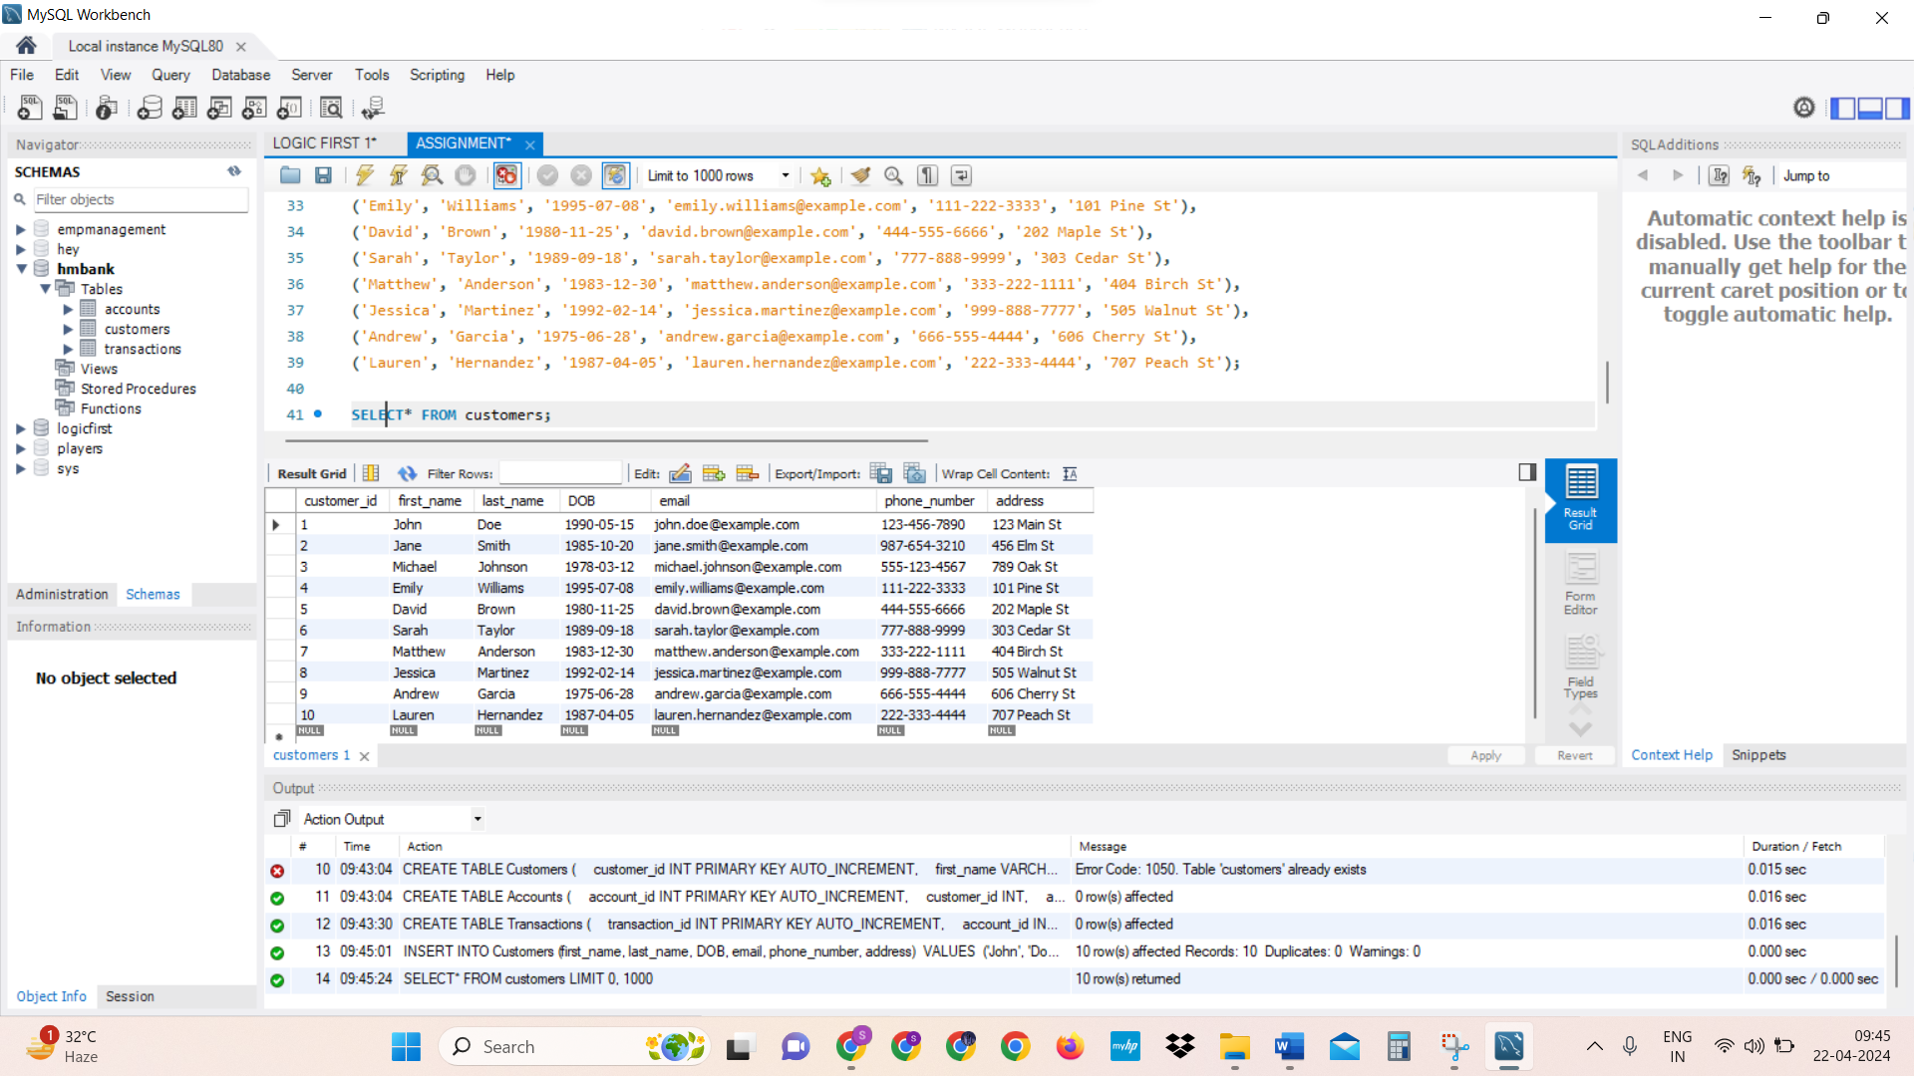

INSERT INTO Accounts (customer_id, account_type, balance)

VALUES

(1, 'savings', 5000.00),

(2, 'current', 2500.00),

(3, 'savings', 7000.00),

(4, 'savings', 3000.00),

(5, 'current', 1500.00),

(6, 'savings', 9000.00),

(7, 'current', 2000.00),

(8, 'savings', 4000.00),

(9, 'current', 3500.00),

(10, 'savings', 6000.00);

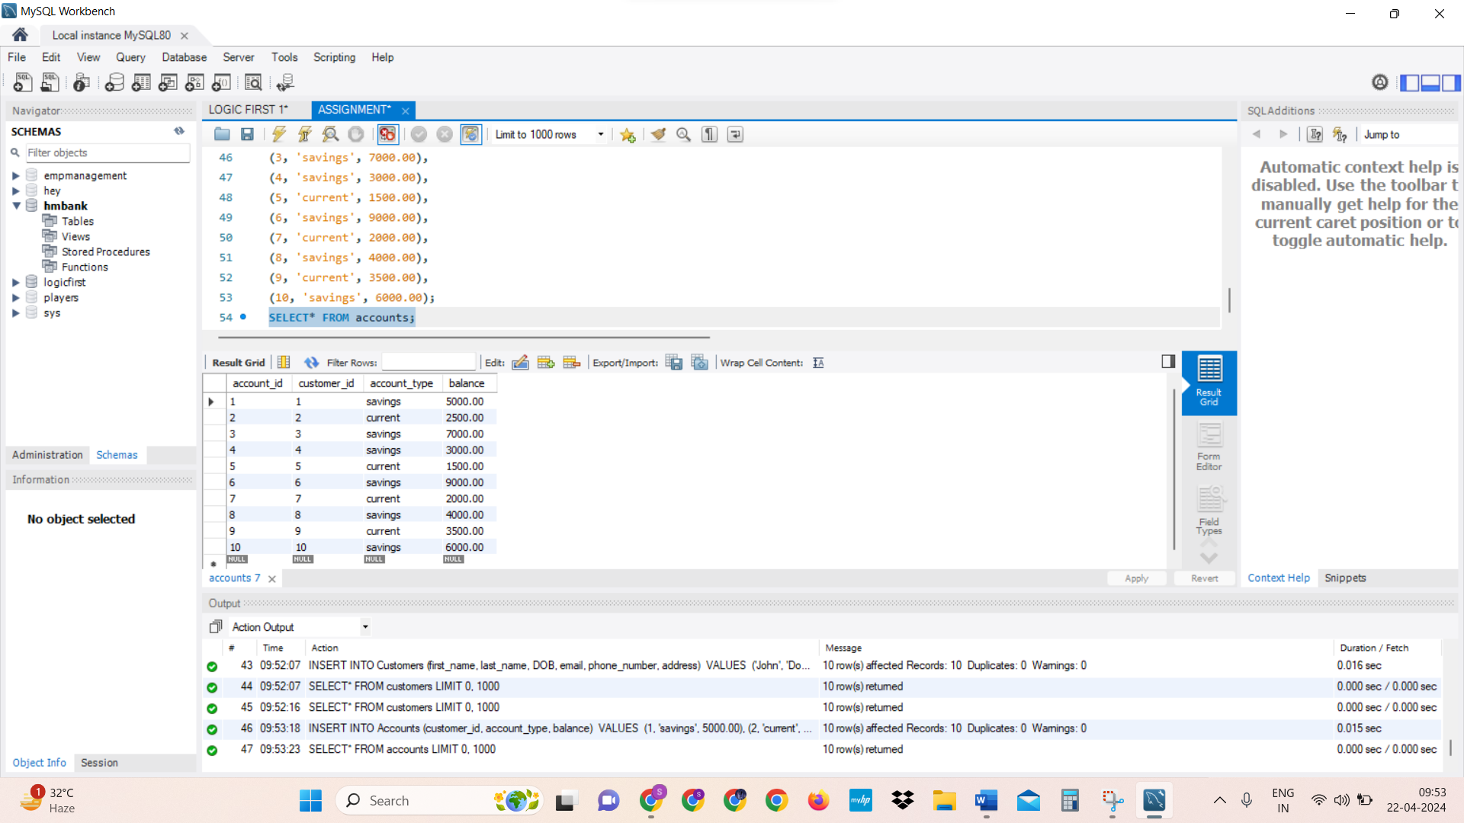

INSERT INTO Transactions (account_id, transaction_type, amount, transaction_date)

VALUES

(1, 'deposit', 1000.00, '2024-04-16 09:30:00'),

(2, 'withdrawal', 500.00, '2024-04-17 13:45:00'),

(3, 'deposit', 2000.00, '2024-04-16 10:15:00'),

(4, 'withdrawal', 1000.00, '2024-04-17 11:20:00'),

(5, 'deposit', 500.00, '2024-04-16 12:30:00'),

(6, 'withdrawal', 1500.00, '2024-04-17 14:00:00'),

(7, 'deposit', 1000.00, '2024-04-16 15:45:00'),

(8, 'withdrawal', 800.00, '2024-04-17 16:30:00'),

(9, 'deposit', 1200.00, '2024-04-16 17:15:00'),

(10, 'withdrawal', 2000.00, '2024-04-17 18:00:00');

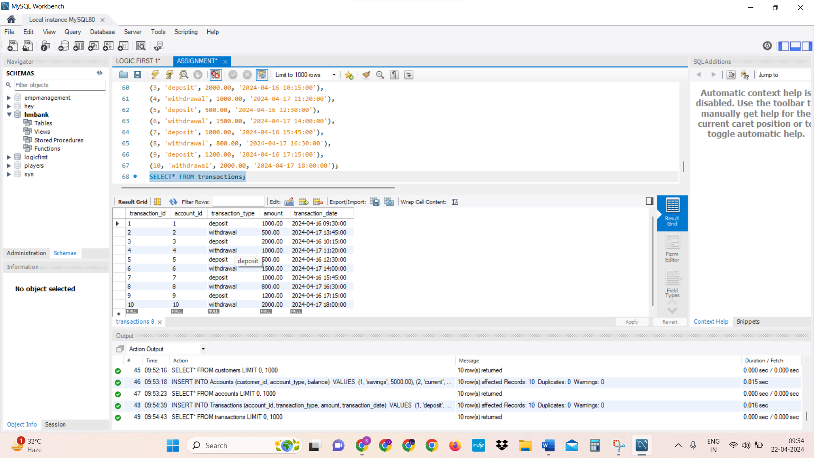

1. Write SQL queries for the following tasks:
2. Write a SQL query to retrieve the name, account type and email of all customers.

**SELECT**

customers.first_name,

customers.last_name,

Accounts.account_type,

customers.email

**FROM** Customers

**INNER JOIN**

Accounts **ON** customers.customer_id = Accounts.customer_id;

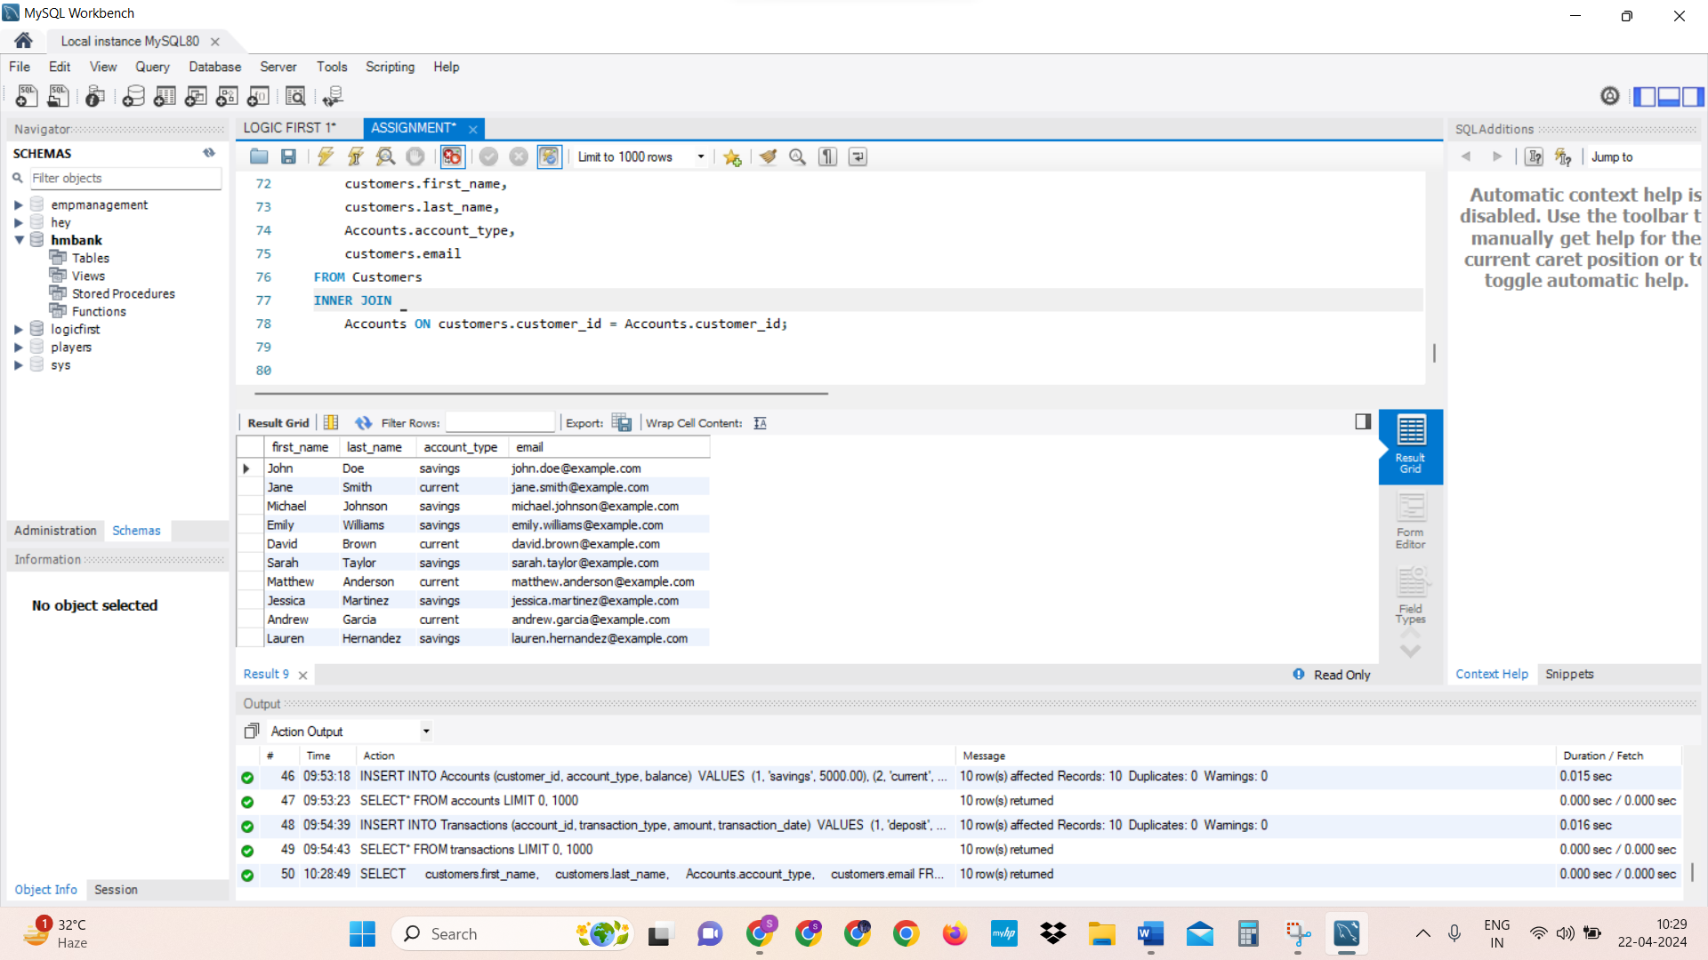

1. Write a SQL query to list all transaction corresponding customer.

**SELECT**

customers.first_name,

customers.last_name,

Transactions.transaction_id,

Transactions.transaction_type,

Transactions.amount,

Transactions.transaction_date

**FROM**

Customers

**INNER JOIN**

Accounts **ON** customers.customer_id = accounts.customer_id

**INNER JOIN**

Transactions **ON** accounts.account_id = Transactions.account_id;

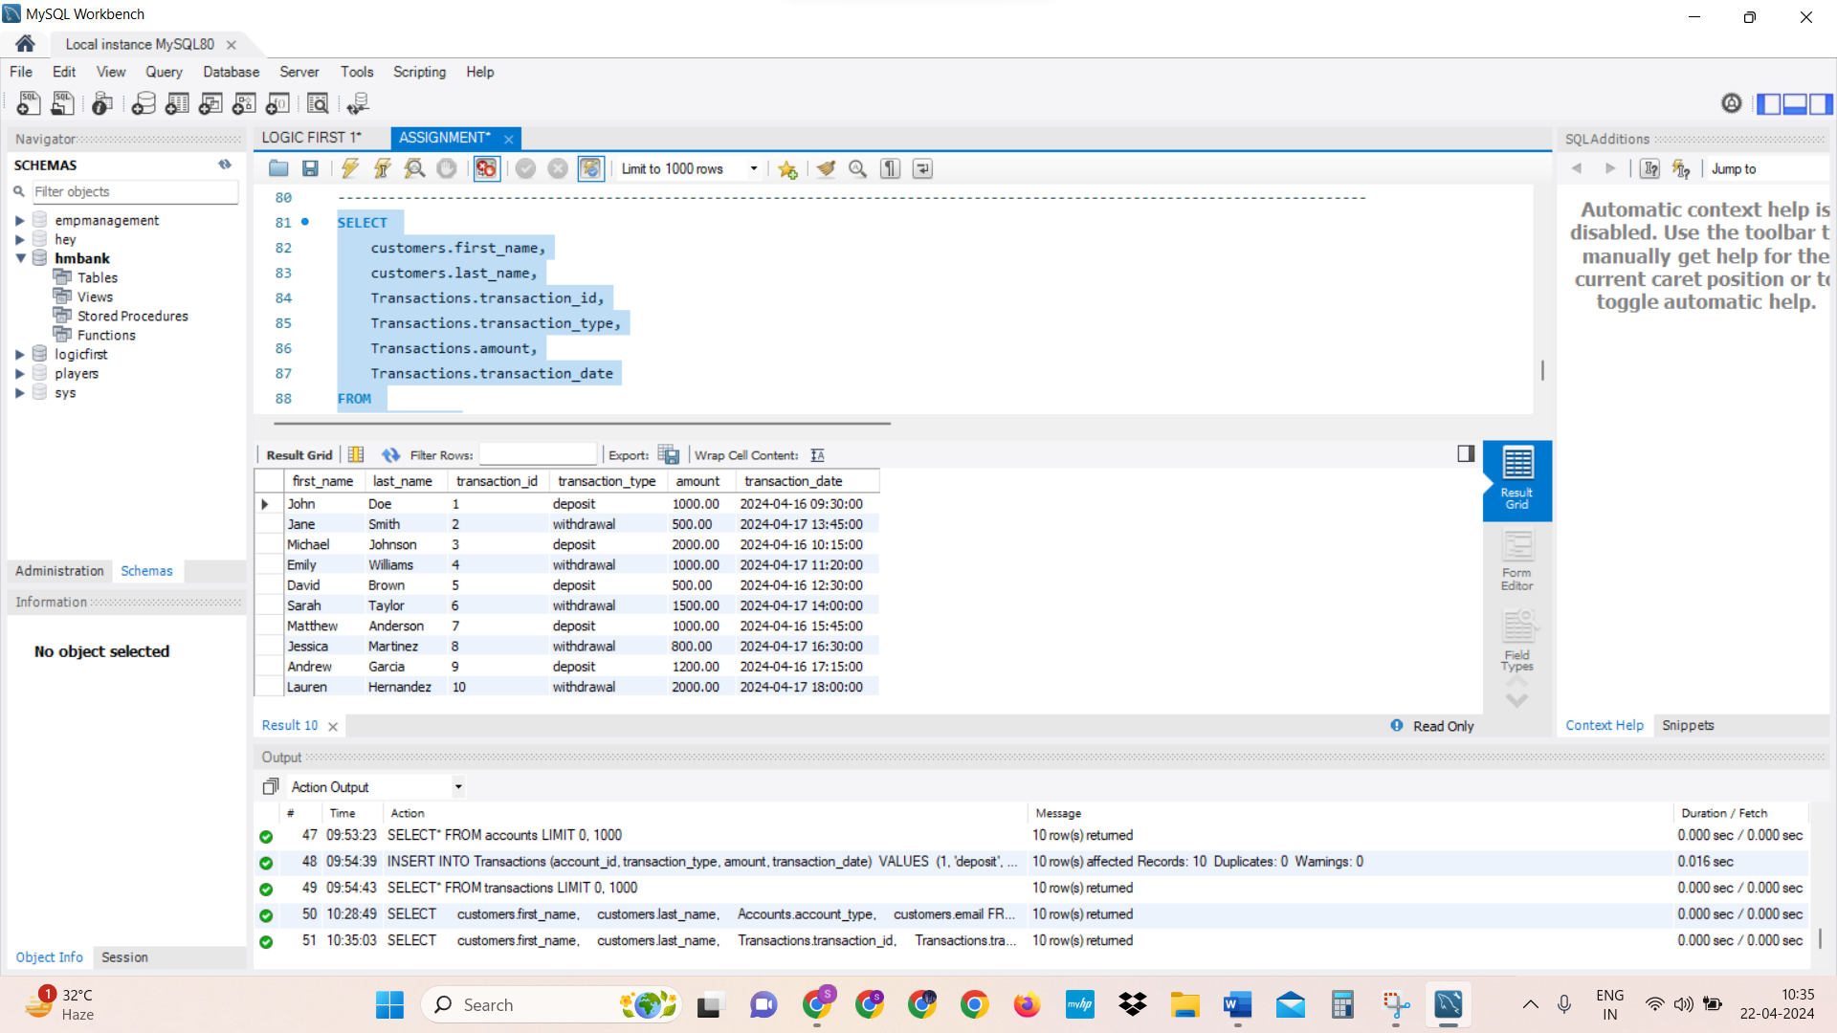

1. Write a SQL query to increase the balance of a specific account by a certain amount.

(8 – Jessica – bal:4000 ----- amount to add: 500)

**UPDATE** Accounts

**SET** balance = balance + 500

**WHERE** account_id = 8;

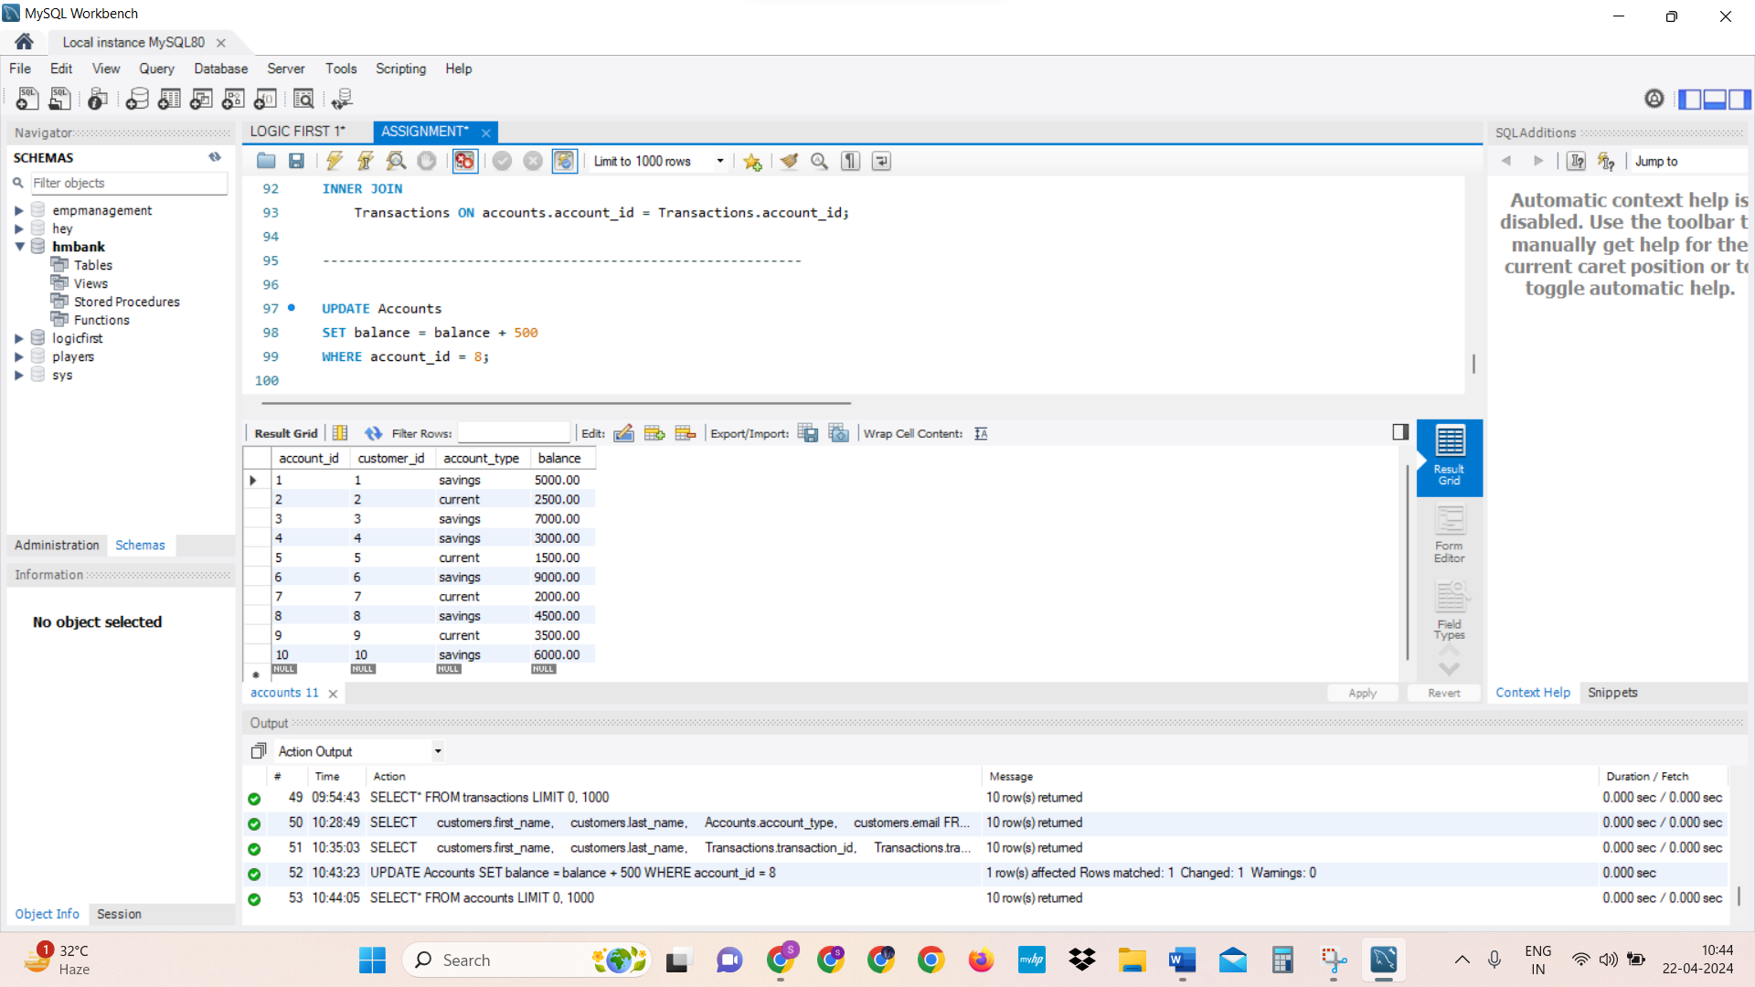

1. Write a SQL query to Combine first and last names of customers as a full_name.

**SELECT**

**CONCAT** (first_name, ' ', last_name) **AS** full_name

**FROM**

Customers;

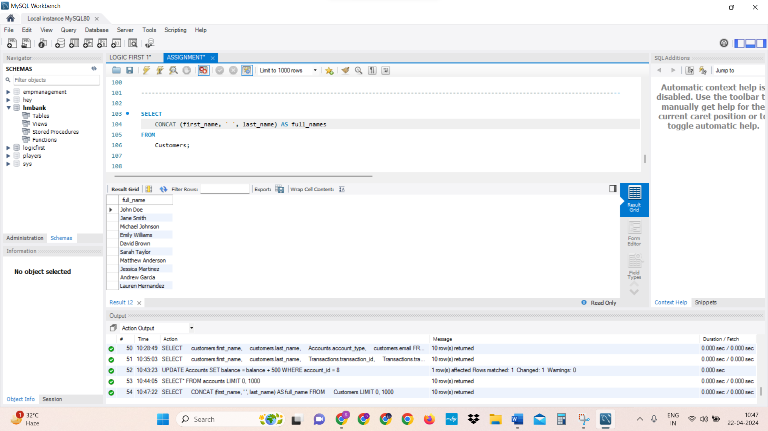

1. Write a SQL query to remove accounts with a balance of zero where the account type is savings.

**DELETE FROM** Accounts

**WHERE** balance = 0;

1. Write a SQL query to Find customers living in a specific city.

**SELECT \***

**FROM**

Customers

**WHERE** Address = ' '505 Walnut St'';

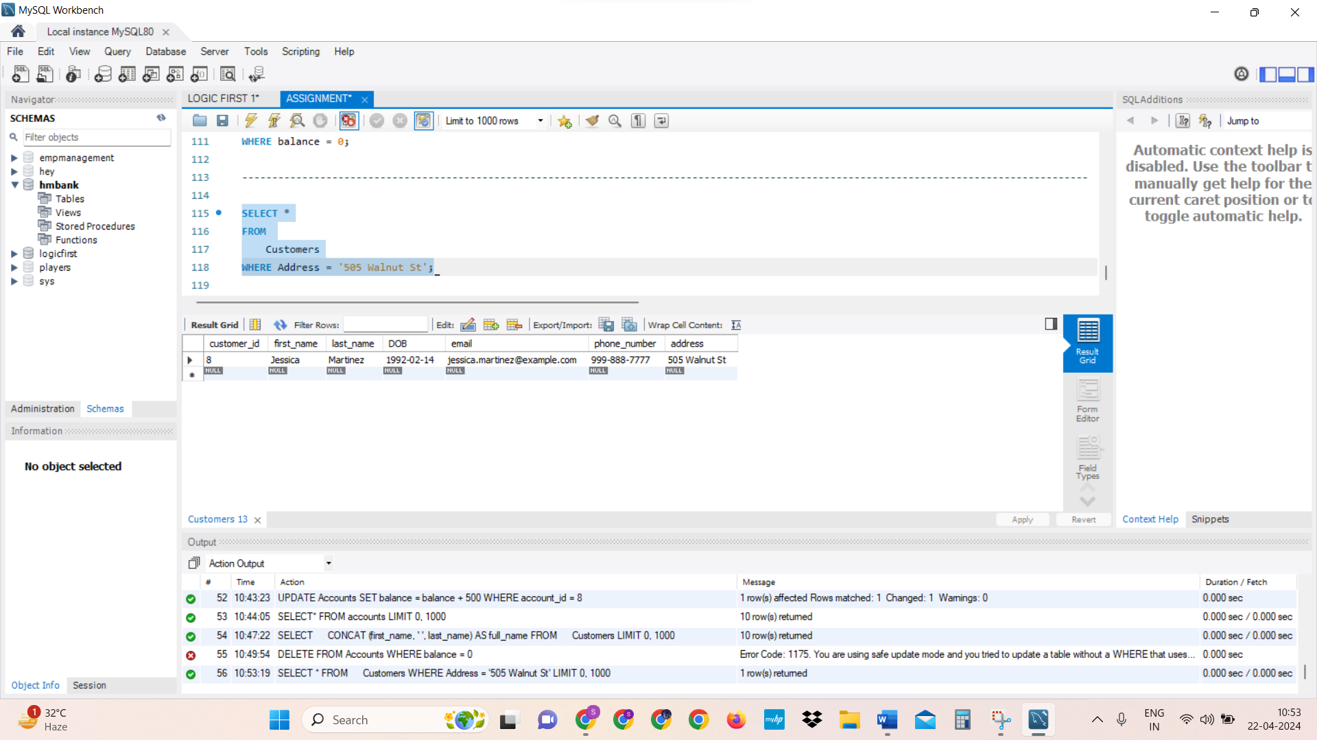

1. Write a SQL query to Get the account balance for a specific account.

**SELECT**

balance

**FROM**

Accounts

**WHERE**

account_id = 8;

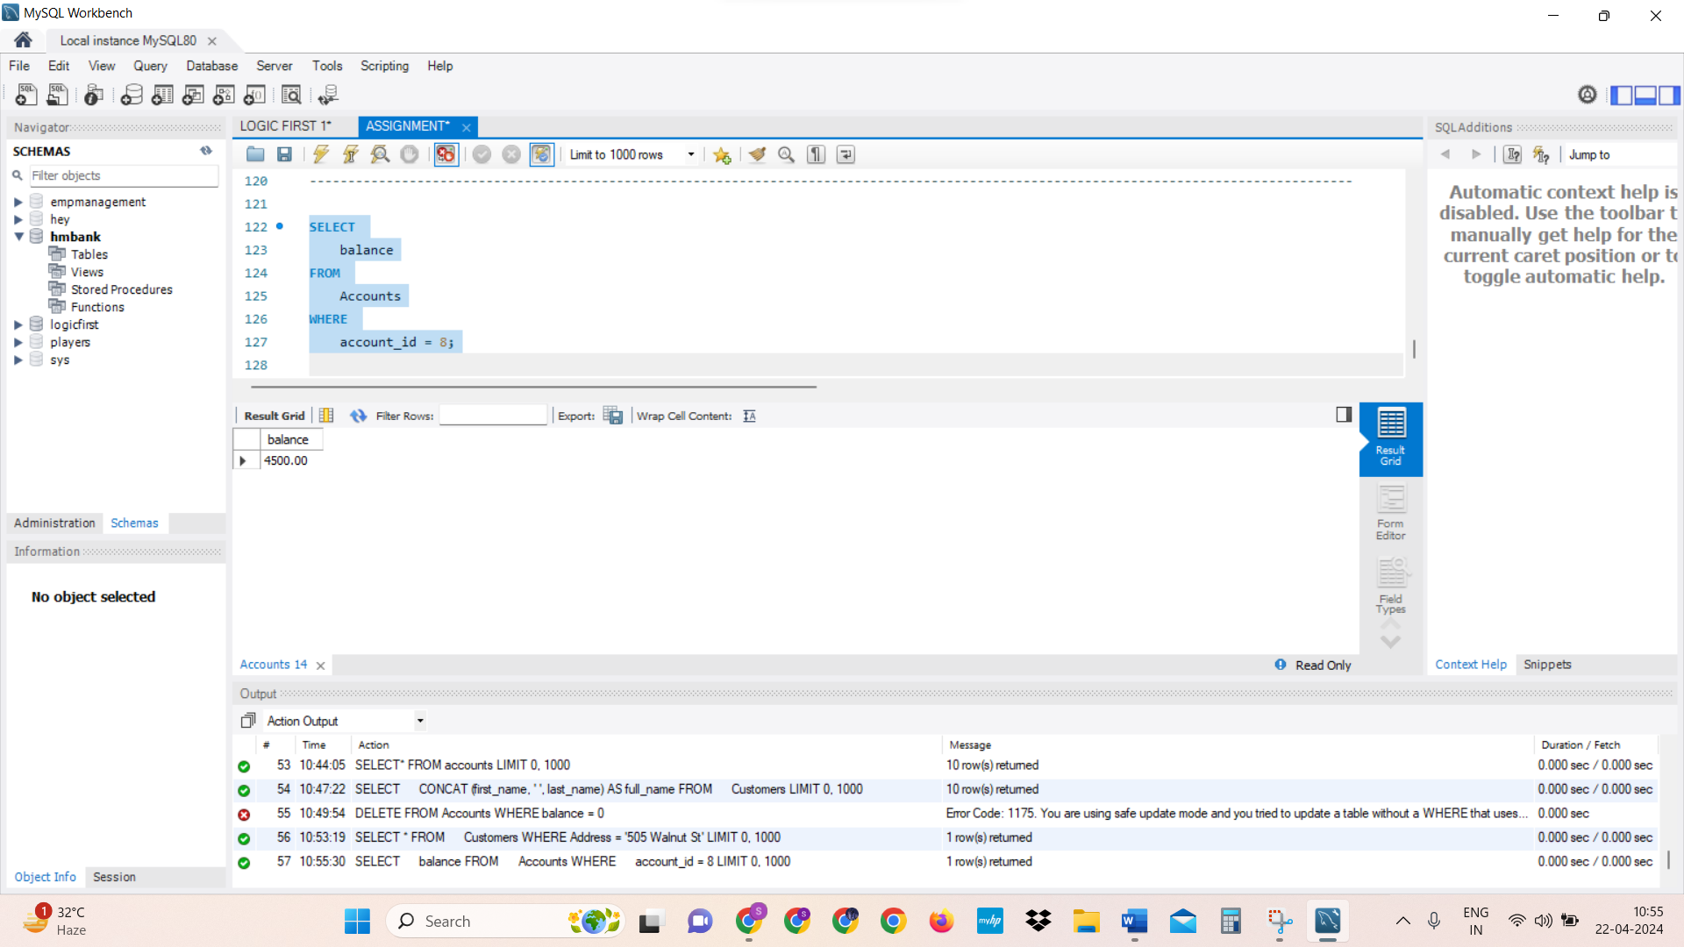

1. Write a SQL query to List all current accounts with a balance greater than 1,000.

SELECT *

FROM

Accounts

WHERE

account_type = 'current' AND balance > 1000.00;

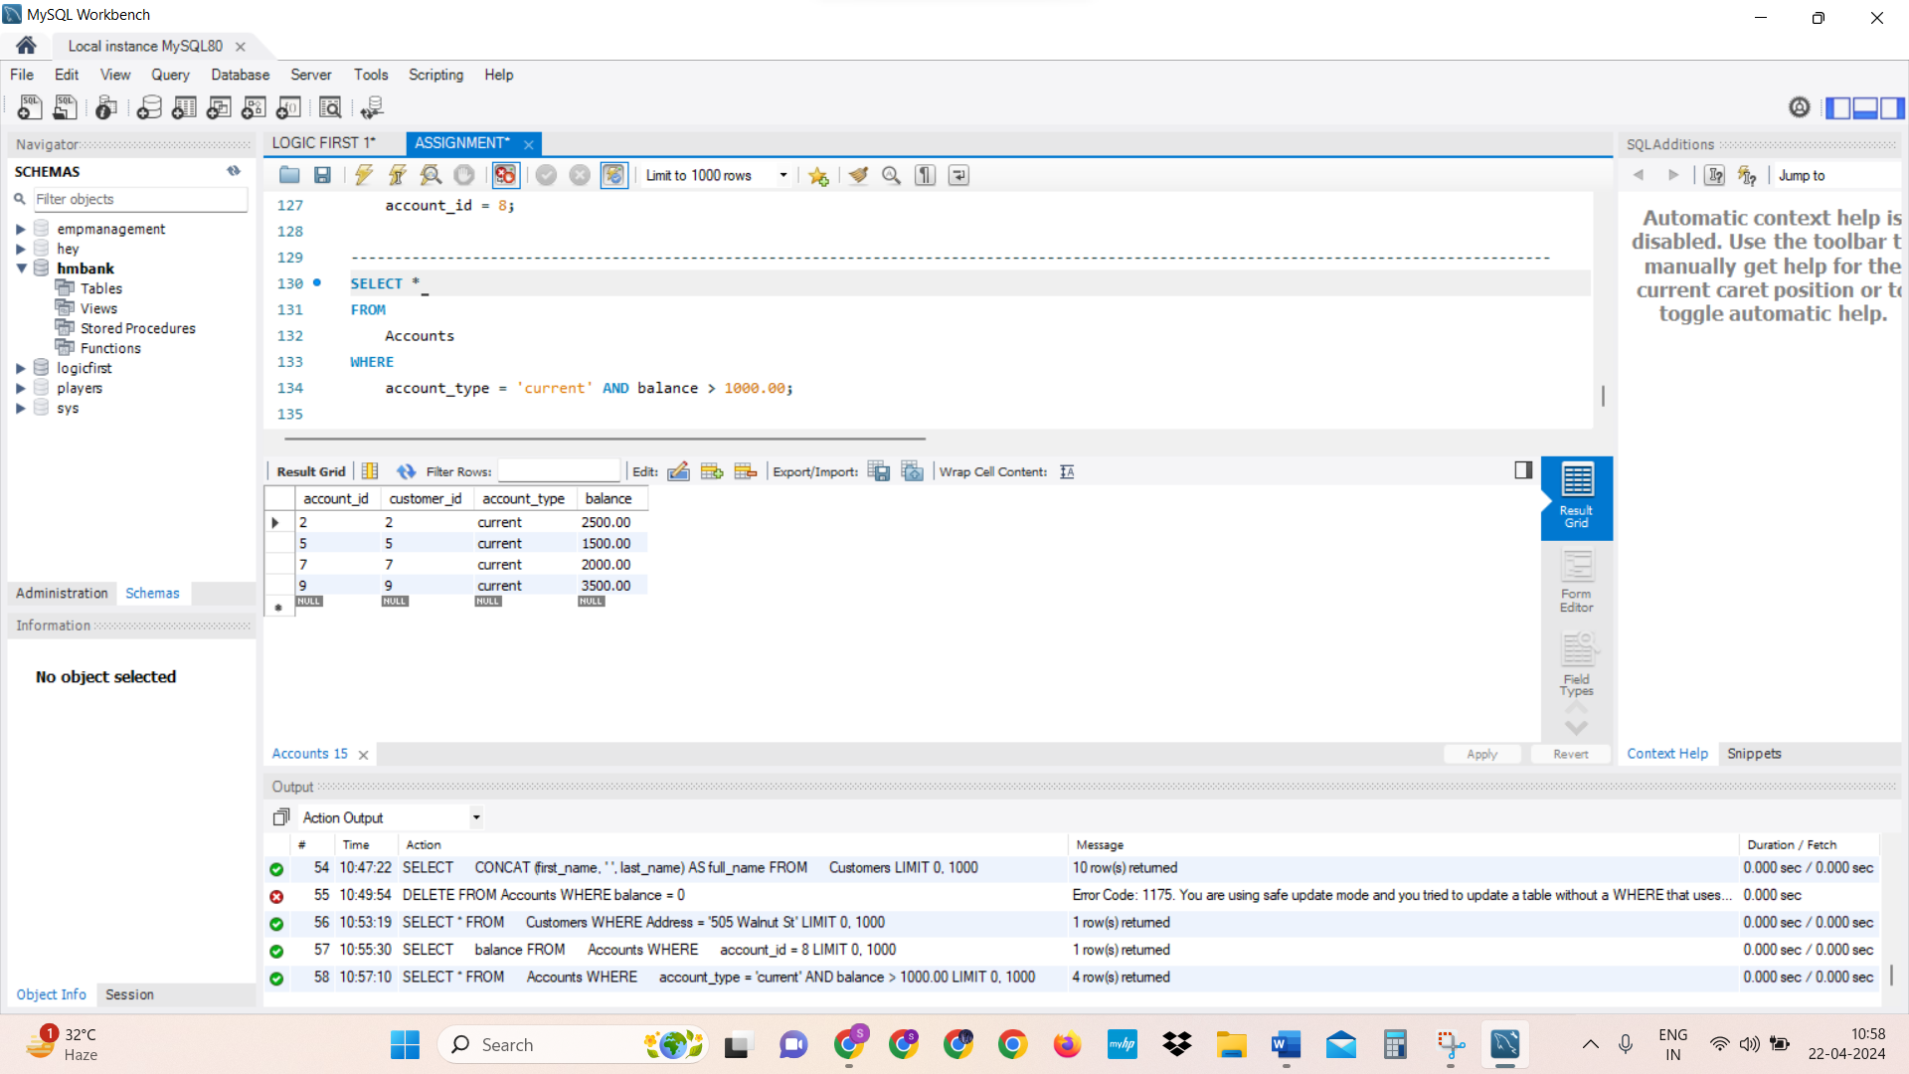

1. Write a SQL query to Retrieve all transactions for a specific account.

SELECT

Transactions.transaction_id,

Transactions.transaction_type,

Transactions.amount,

Transactions.transaction_date

FROM

Transactions

INNER JOIN

Accounts ON Transactions.account_id = Accounts.account_id

WHERE

Accounts.account_id = 8;

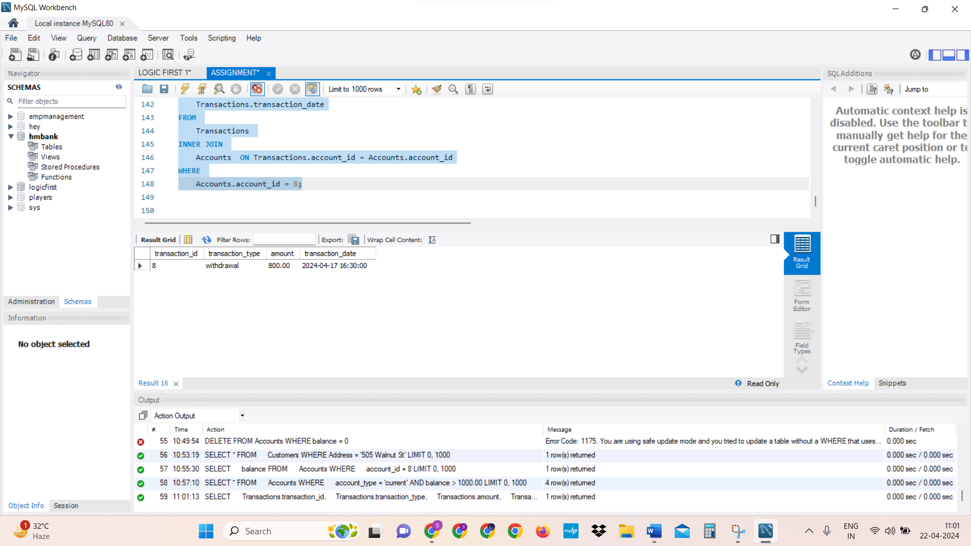

10. Write a SQL query to Calculate the interest accrued on savings accounts based on a

given interest rate.

ASSUMING INTEREST RATE – 7% ----- 0.07

SELECT

account_id,

balance * 0.07 AS interest_accrued

FROM

Accounts

WHERE account_type = 'savings';

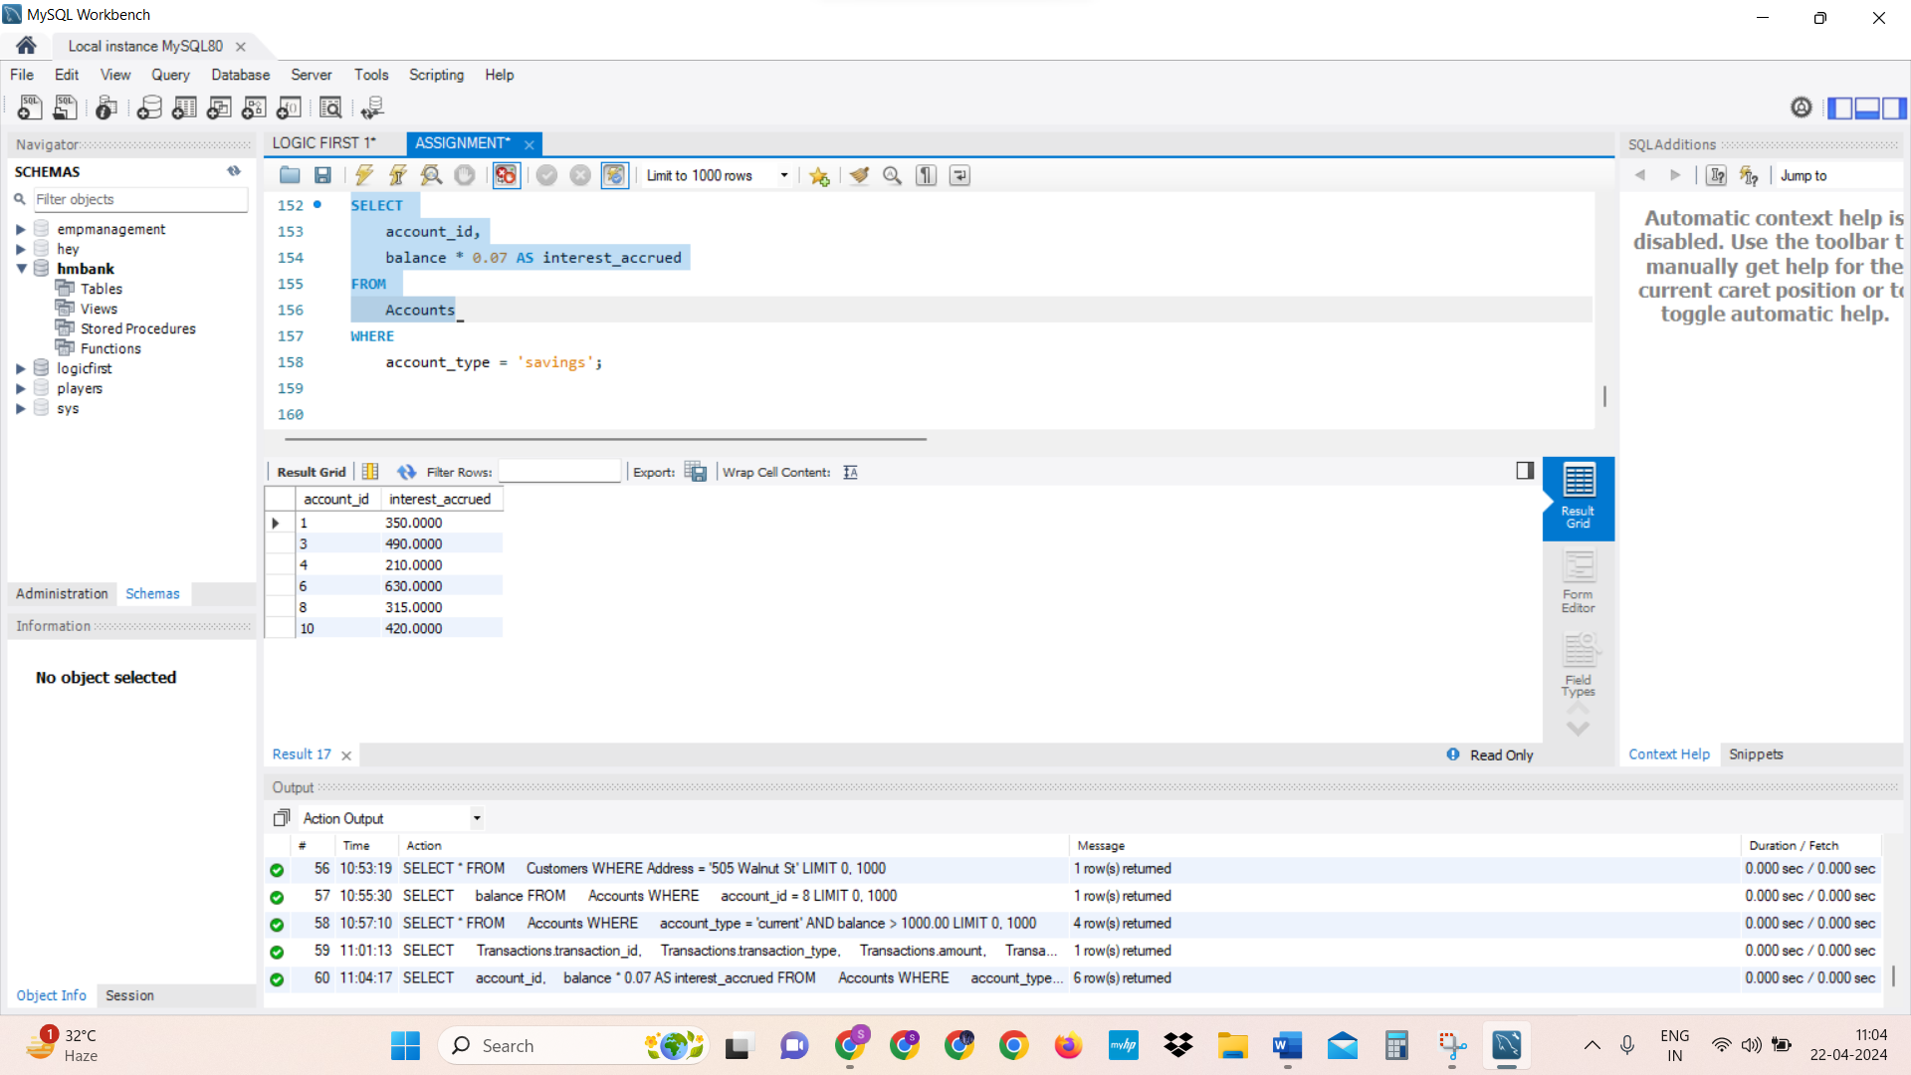

11. Write a SQL query to Identify accounts where the balance is less than a specified

overdraft limit.

SELECT

account_id, balance

FROM

Accounts

WHERE balance < 6000.00;

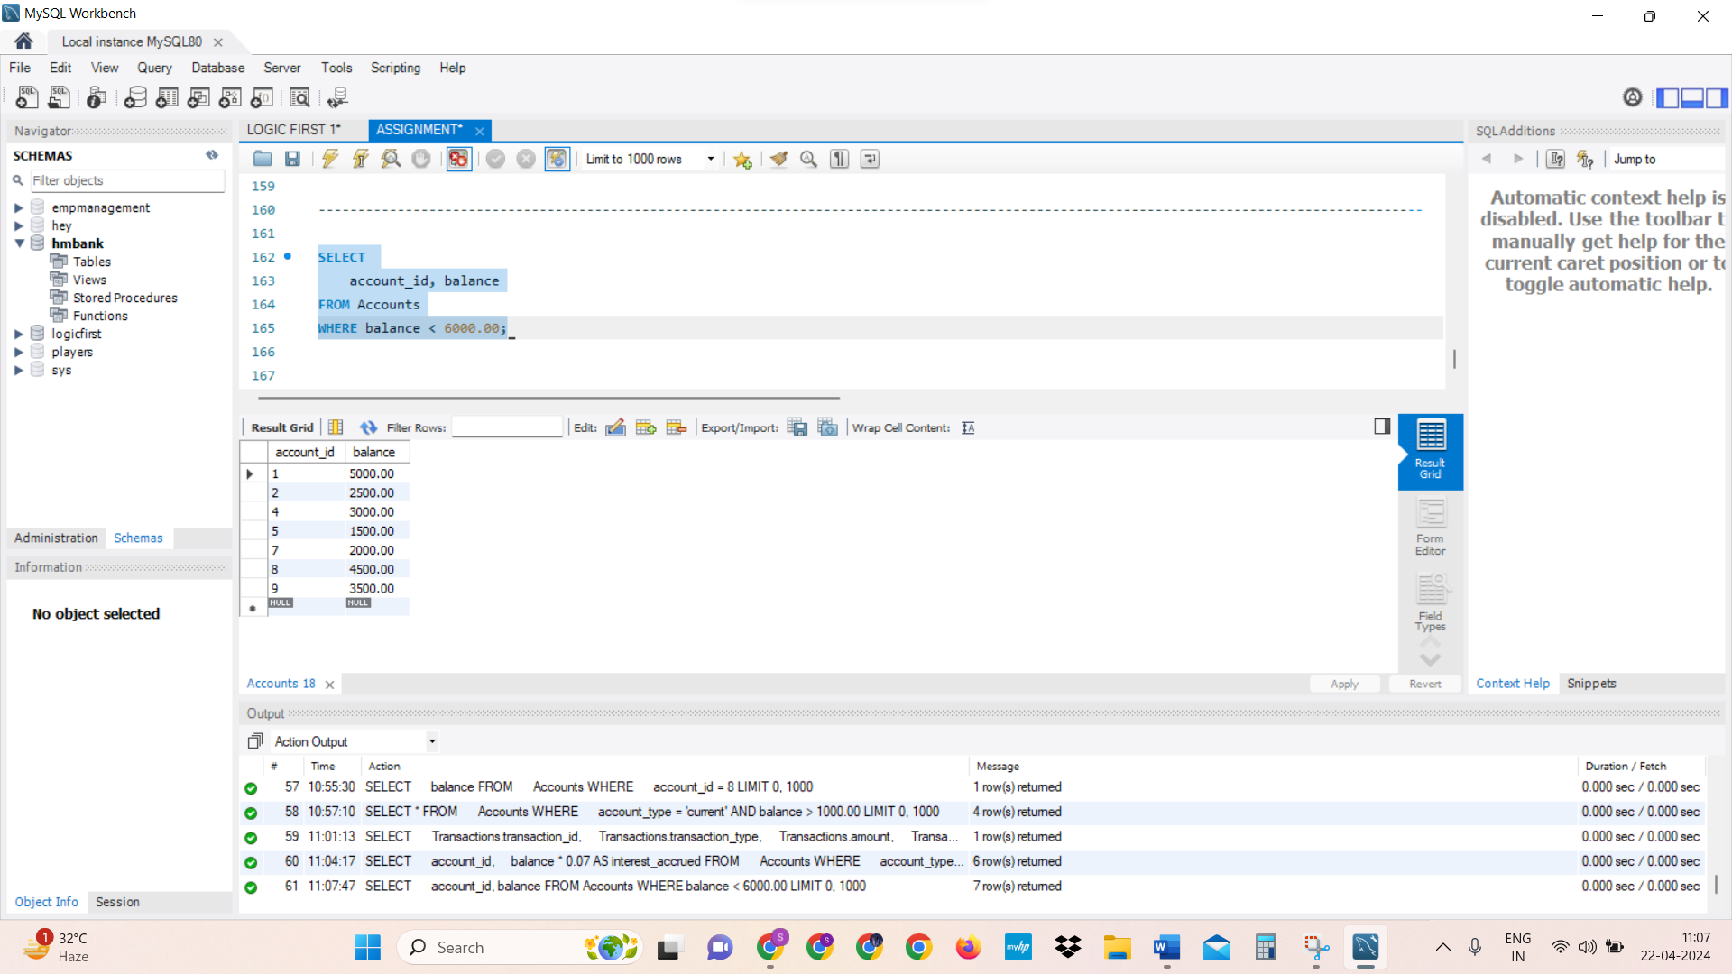

12. Write a SQL query to Find customers not living in a specific city.

SELECT *

FROM

Customers

WHERE

address <> '789 Oak St';

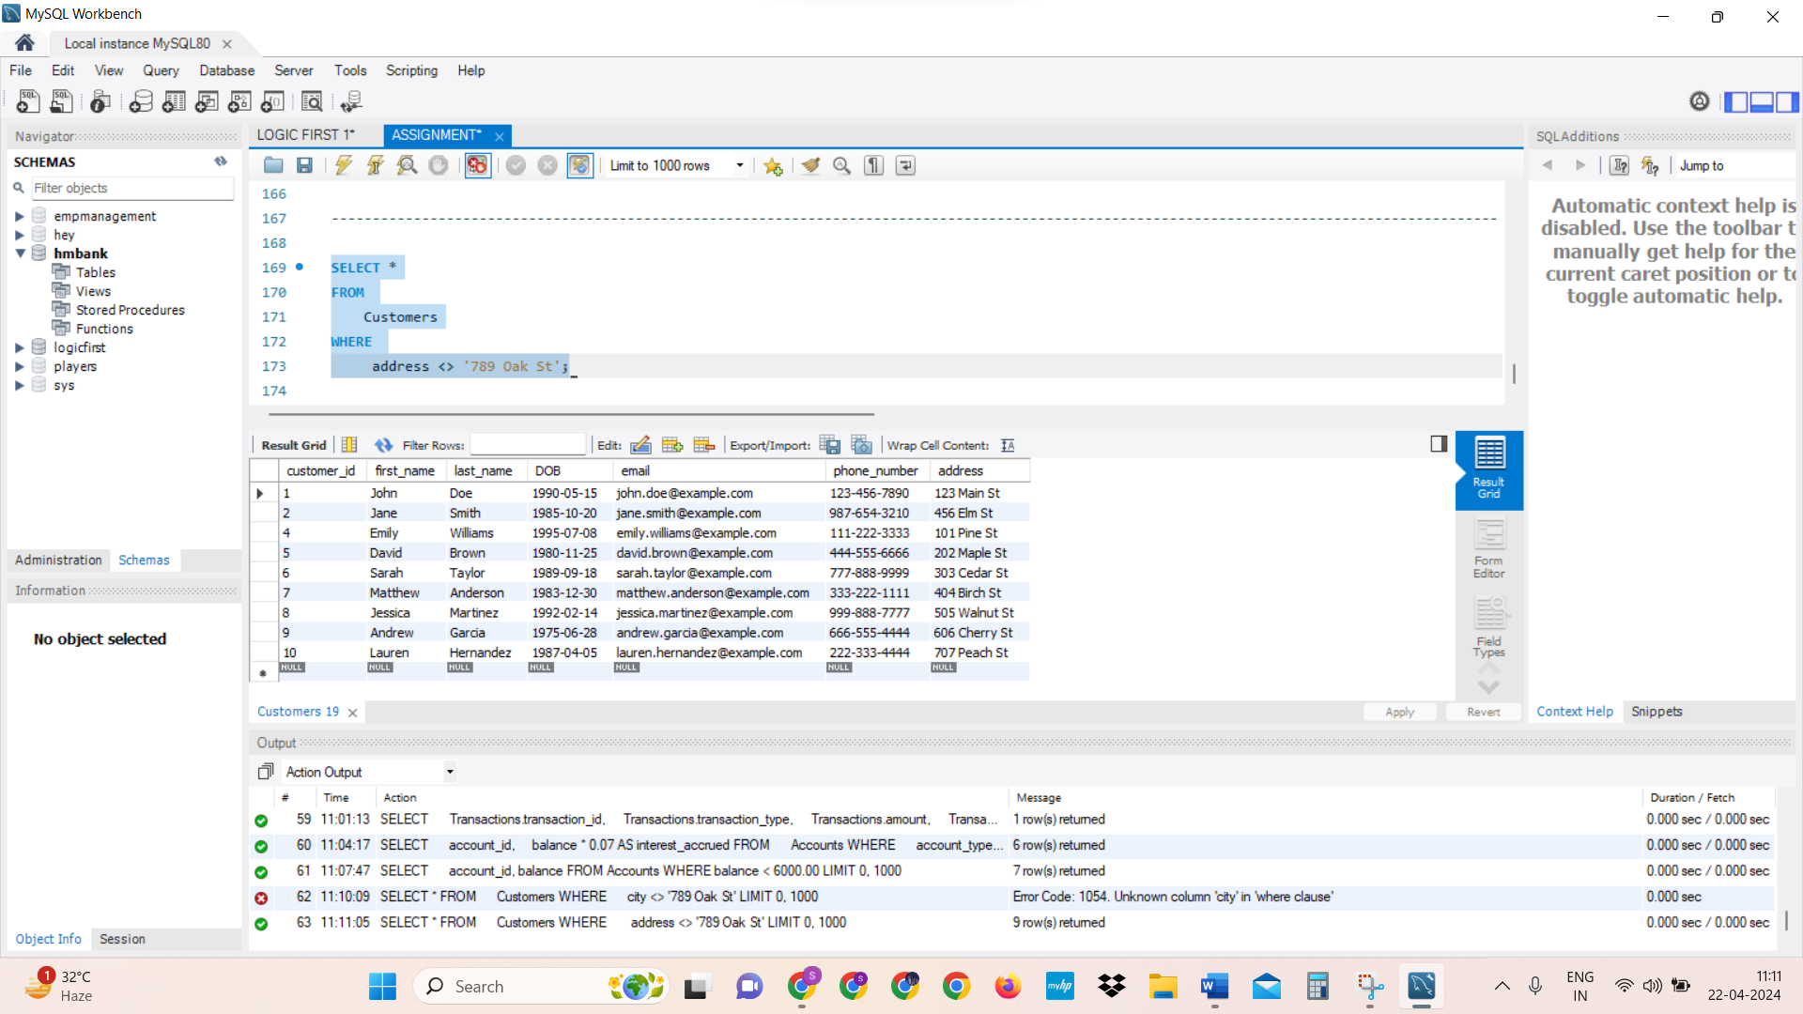

**TASK 3:**

**Aggregate functions, Having, Order By, GroupBy and Joins:**

1. Write a SQL query to Find the average account balance for all customers.

SELECT AVG (balance) AS average_balance

FROM Accounts;

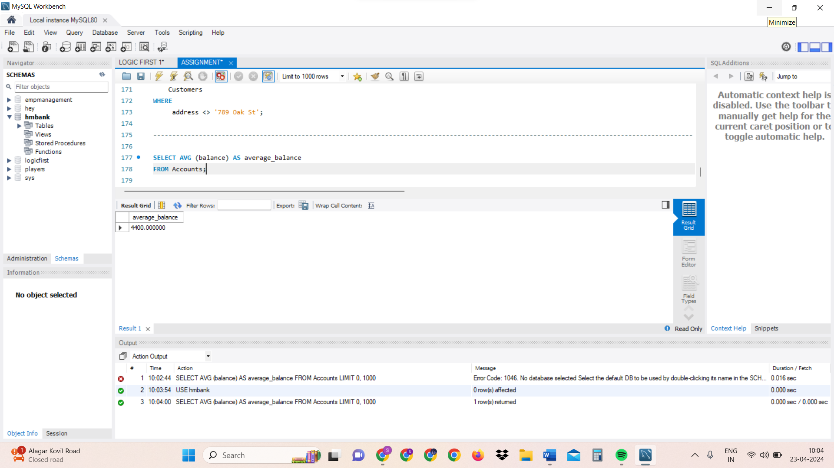

1. Write a SQL query to Retrieve the top 10 highest account balances.

SELECT *

FROM Accounts

ORDER BY balance DESC

LIMIT 10;

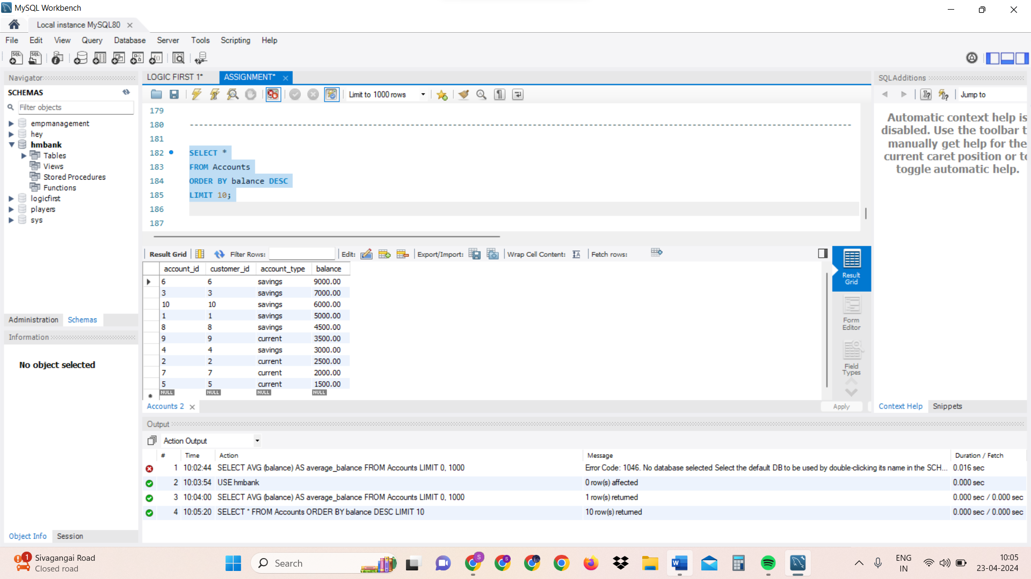

1. Write a SQL query to Calculate Total Deposits for All Customers in specific date.

SELECT SUM(amount) AS total_deposits

FROM Transactions

WHERE transaction_type = 'deposit'

AND DATE(transaction_date) = ' 2024-04-16';

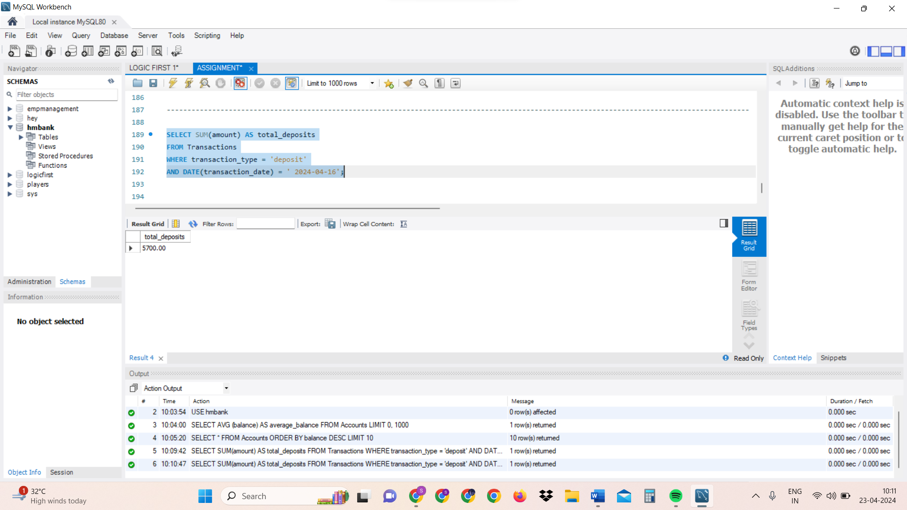

1. Write a SQL query to Find the Oldest and Newest Customers.

(BELOW QUERY WRONG)

SELECT

MIN(DOB) AS oldest_customer_DOB,

MAX(DOB) AS newest_customer_DOB

FROM Customers;

Or

-- Oldest Customers:

SELECT

c.customer_id,

c.first_name,

c.last_name,

MIN(t.transaction_date) AS oldest_transaction_date

FROM

Customers c

INNER JOIN

Accounts a ON c.customer_id = a.customer_id

INNER JOIN

Transactions t ON a.account_id = t.account_id

GROUP BY

c.customer_id, c.first_name, c.last_name

ORDER BY

oldest_transaction_date ASC

LIMIT 1;

-----HERE GRP BY USED TO GRP SIMILAR ROWS OF SAME CUSTOMER ID (IN CASE IF GIVEN) TO BE GROUPED TOGETHER NEXT TO NEXT

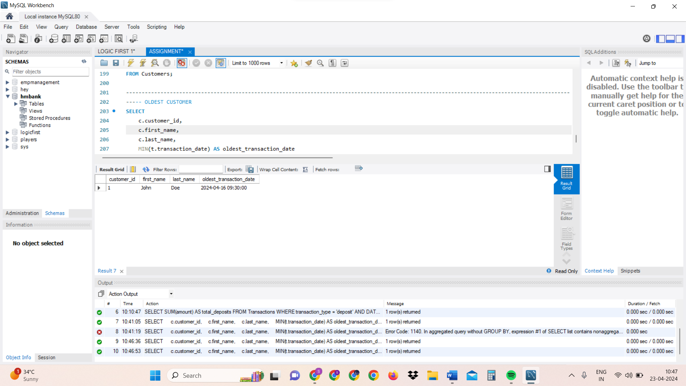

-- Newest Customers

SELECT

c.customer_id,

c.first_name,

c.last_name,

MAX(t.transaction_date) AS newest_transaction_date

FROM

Customers c

INNER JOIN

Accounts a ON c.customer_id = a.customer_id

INNER JOIN

Transactions t ON a.account_id = t.account_id

GROUP BY

c.customer_id, c.first_name, c.last_name

ORDER BY

newest_transaction_date DESC

LIMIT 1;

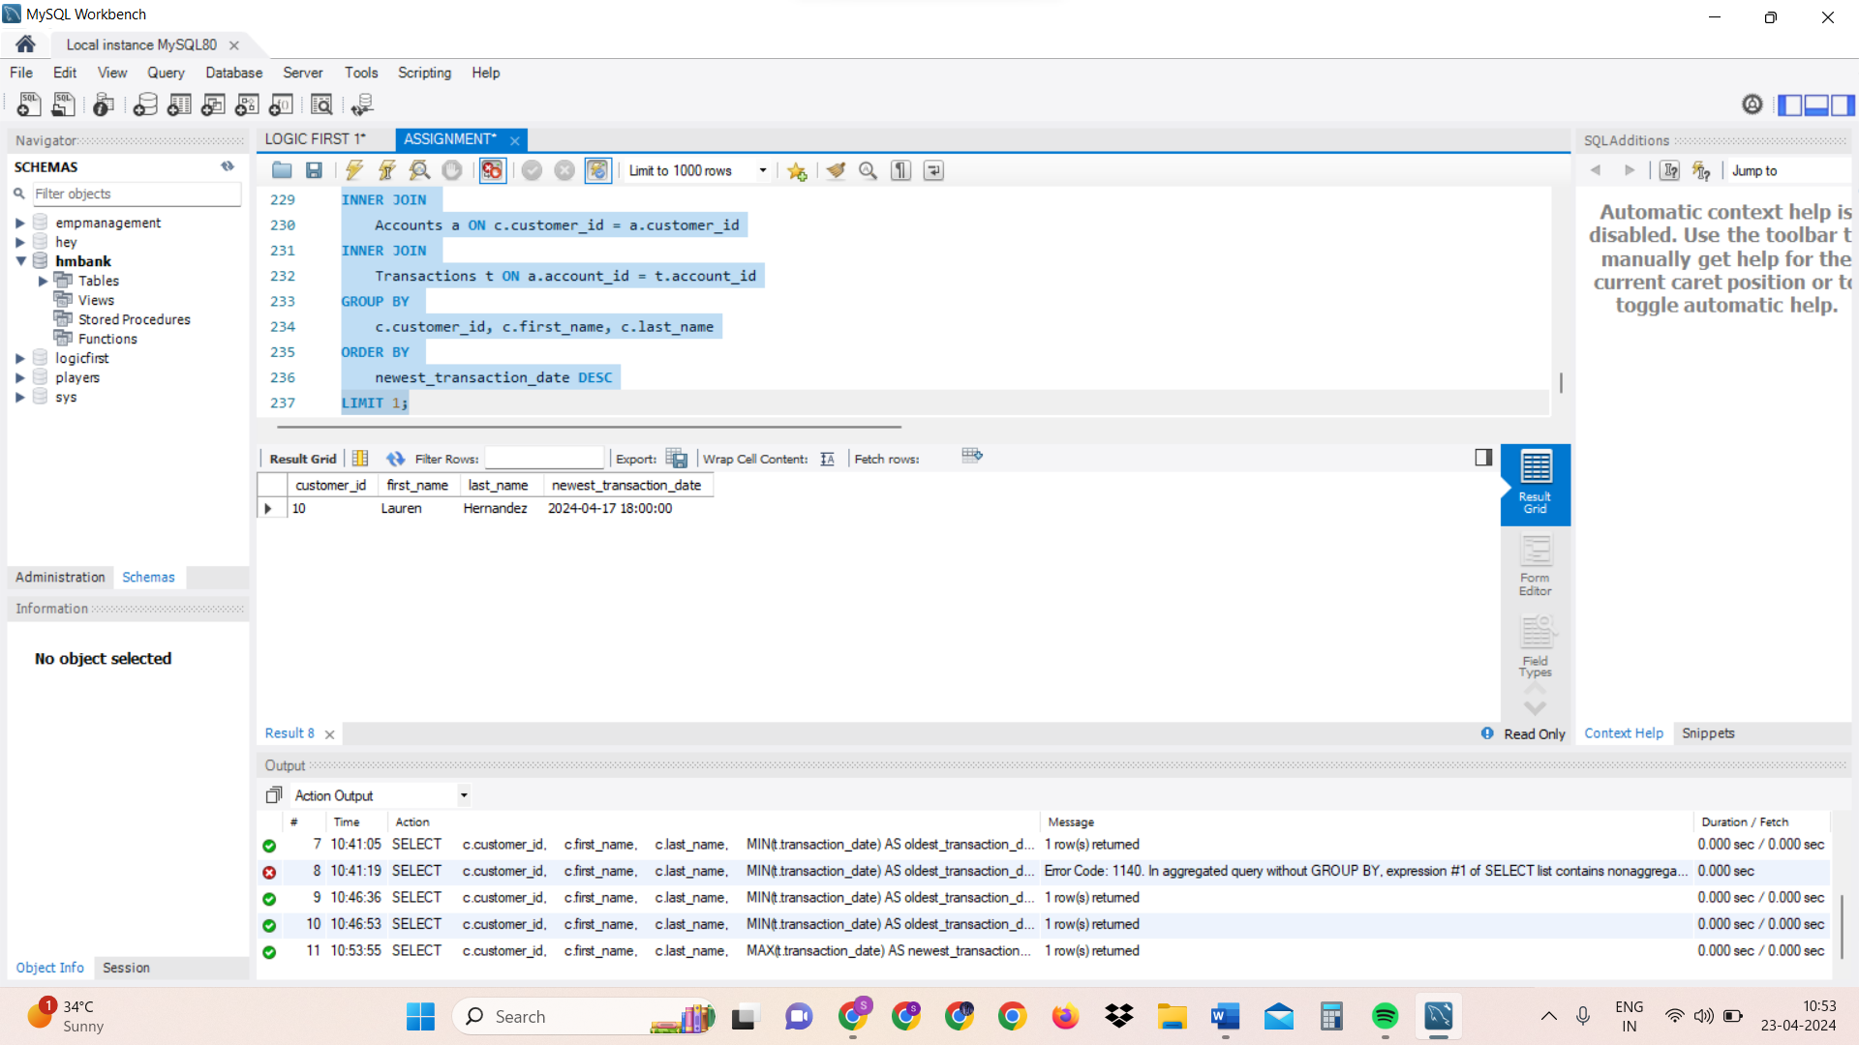

1. Write a SQL query to Retrieve transaction details along with the account type.

SELECT

Transactions.*,

Accounts.account_type

FROM Transactions

INNER JOIN

Accounts ON Transactions.account_id = Accounts.account_id;

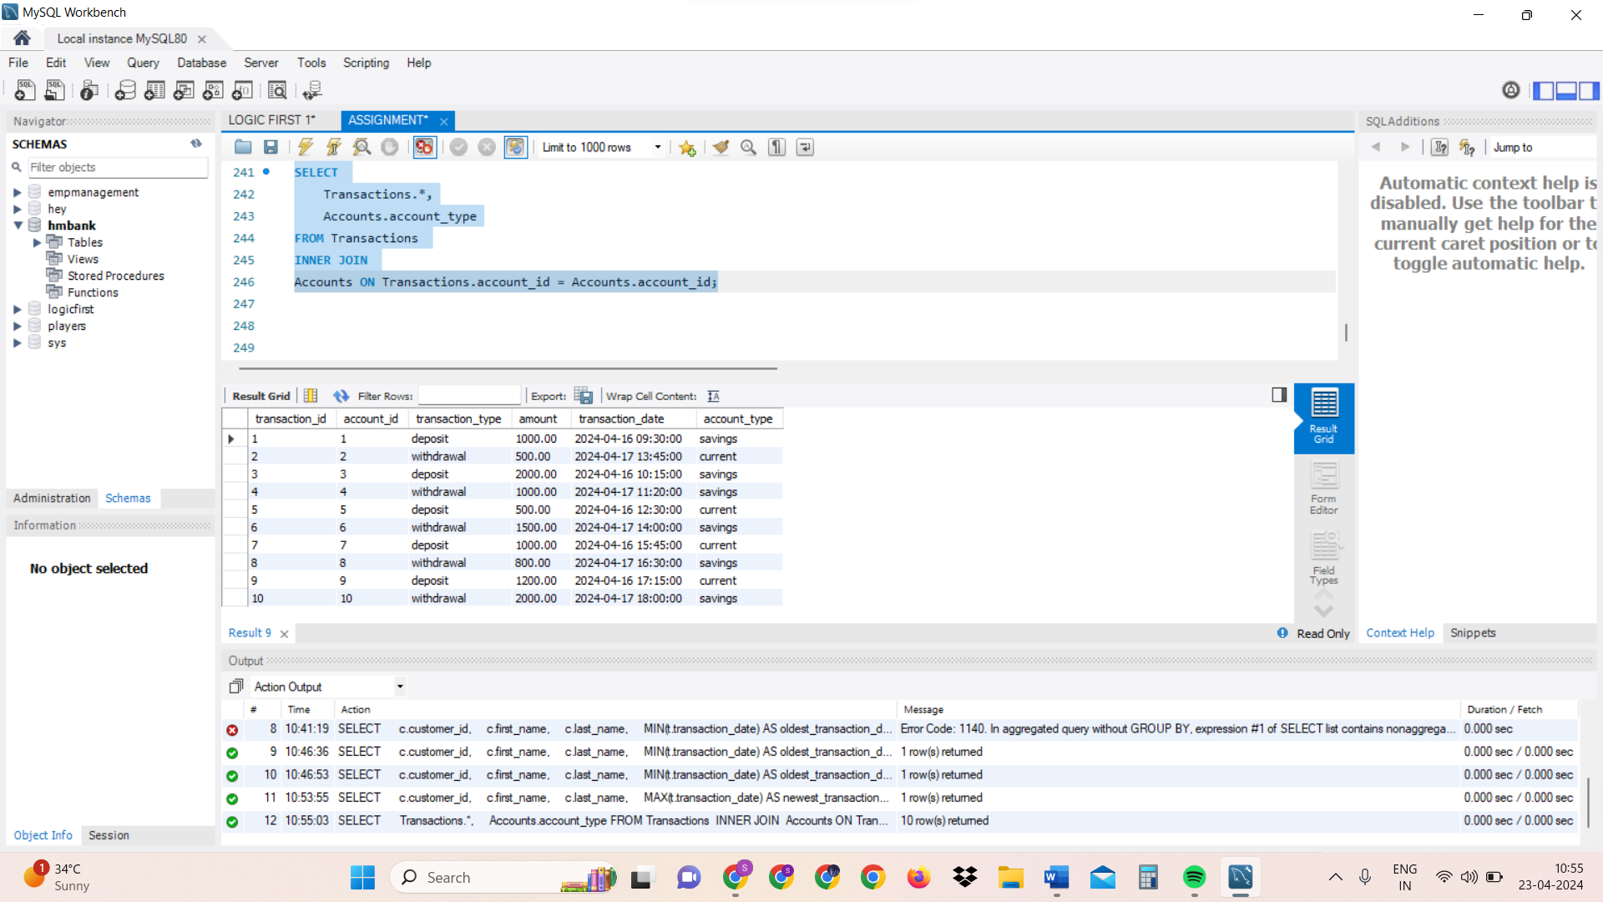

1. Write a SQL query to Get a list of customers along with their account details.

SELECT

Customers.*,

Accounts.*

FROM Customers

INNER JOIN Accounts ON Customers.customer_id = Accounts.customer_id;

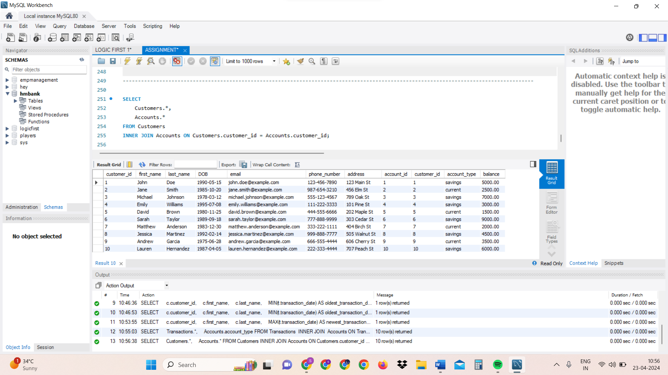

1. Write a SQL query to Retrieve transaction details along with customer information for a specific account.

SELECT

Transactions.*,

Customers.*

FROM Transactions

INNER JOIN Accounts ON Transactions.account_id = accounts.account_id

INNER JOIN Customers ON accounts.customer_id = Customers.customer_id

WHERE accounts.account_id = 3;

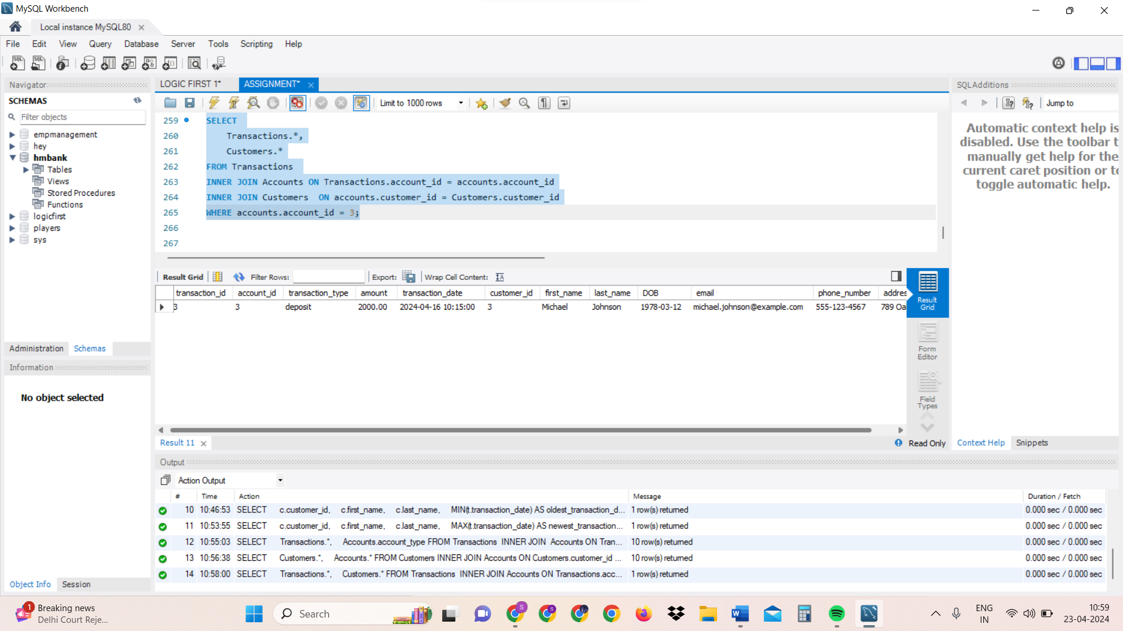

1. Write a SQL query to Identify customers who have more than one account.

SELECT

customer_id,

COUNT(*) AS num_of_accounts

FROM Accounts

GROUP BY customer_id

HAVING COUNT(*) > 1;

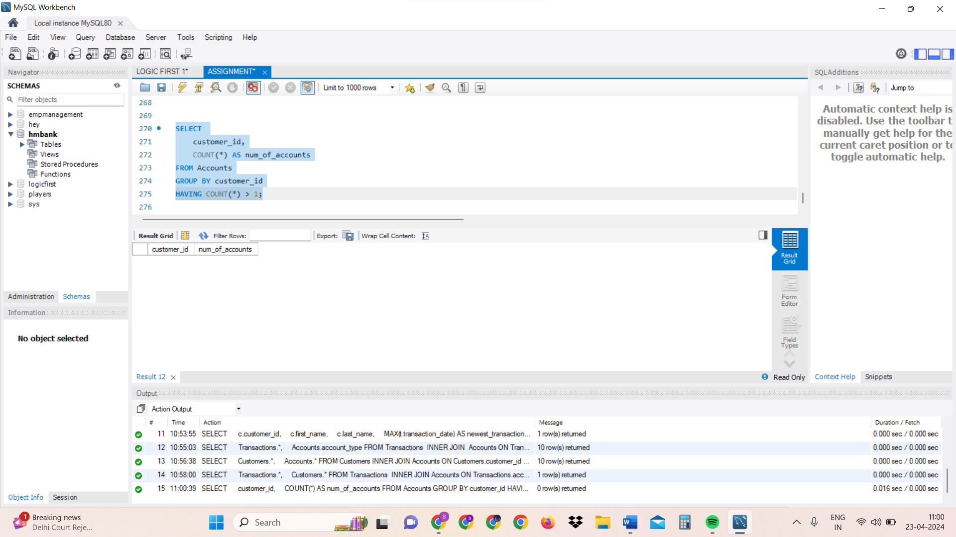

1. Write a SQL query to Calculate the difference in transaction amounts between deposits and withdrawals.

SELECT

account_id,

SUM(CASE WHEN transaction_type = 'deposit' THEN amount ELSE -amount END) AS transaction_difference

FROM Transactions

GROUP BY account_id;

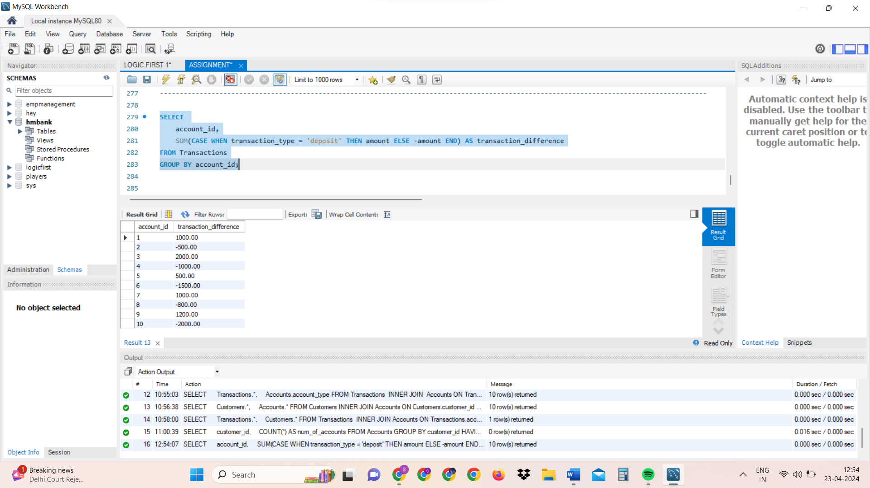

1. Write a SQL query to Calculate the average daily balance for each account over a specified period.

SELECT

t.account_id,

AVG(a.balance) AS average_daily_balance

FROM

Transactions t

INNER JOIN

Accounts a ON t.account_id = a.account_id

WHERE

t.transaction_date BETWEEN '2024-04-15' AND '2024-04-18'

GROUP BY

t.account_id;

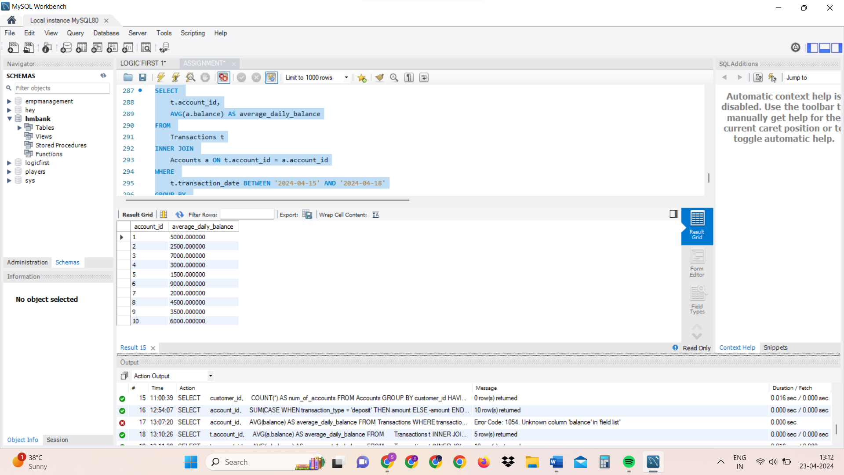

1. Calculate the total balance for each account type.

SELECT

a.account_type,

SUM(a.balance) AS total_balance

FROM

Accounts a

GROUP BY

a.account_type;

OR

(SINCE WE DON’T HAVE 2 TABLES HERE, WE CAN SIMPLY MENTION ABT ACCOUNTS TABLE ITSELF)

SELECT

account_type,

SUM(balance) AS total_balance

FROM Accounts

GROUP BY account_type;

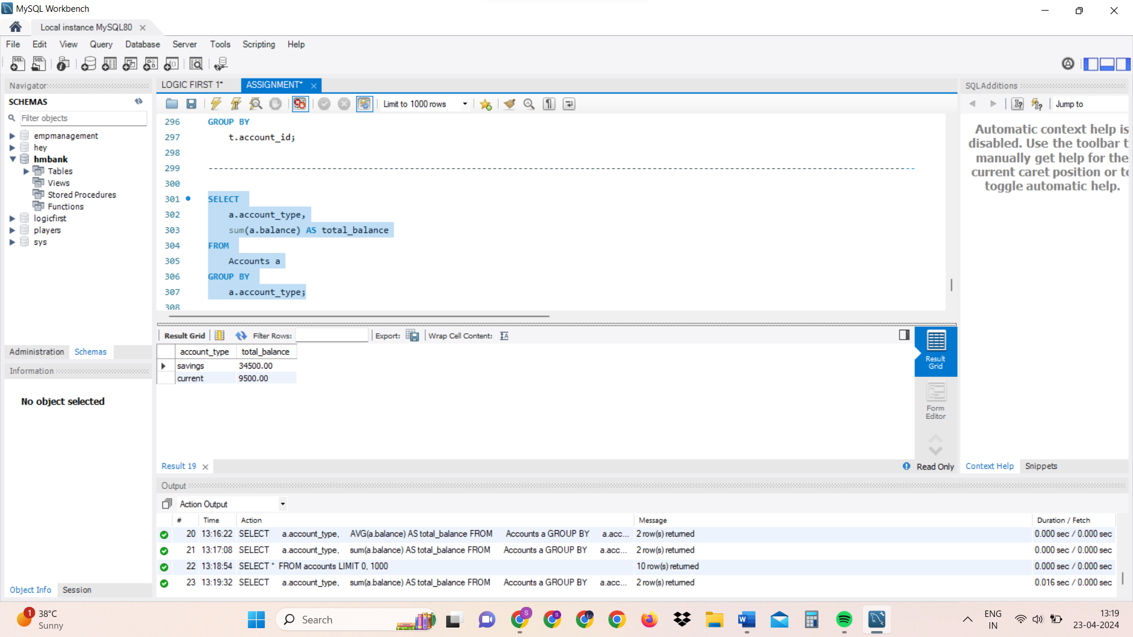

1. Identify accounts with the highest number of transactions order by descending order.

SELECT

account_id,

COUNT(*) AS num_of_transactions

FROM Accounts

GROUP BY account_id

ORDER BY num_of_transactions DESC;

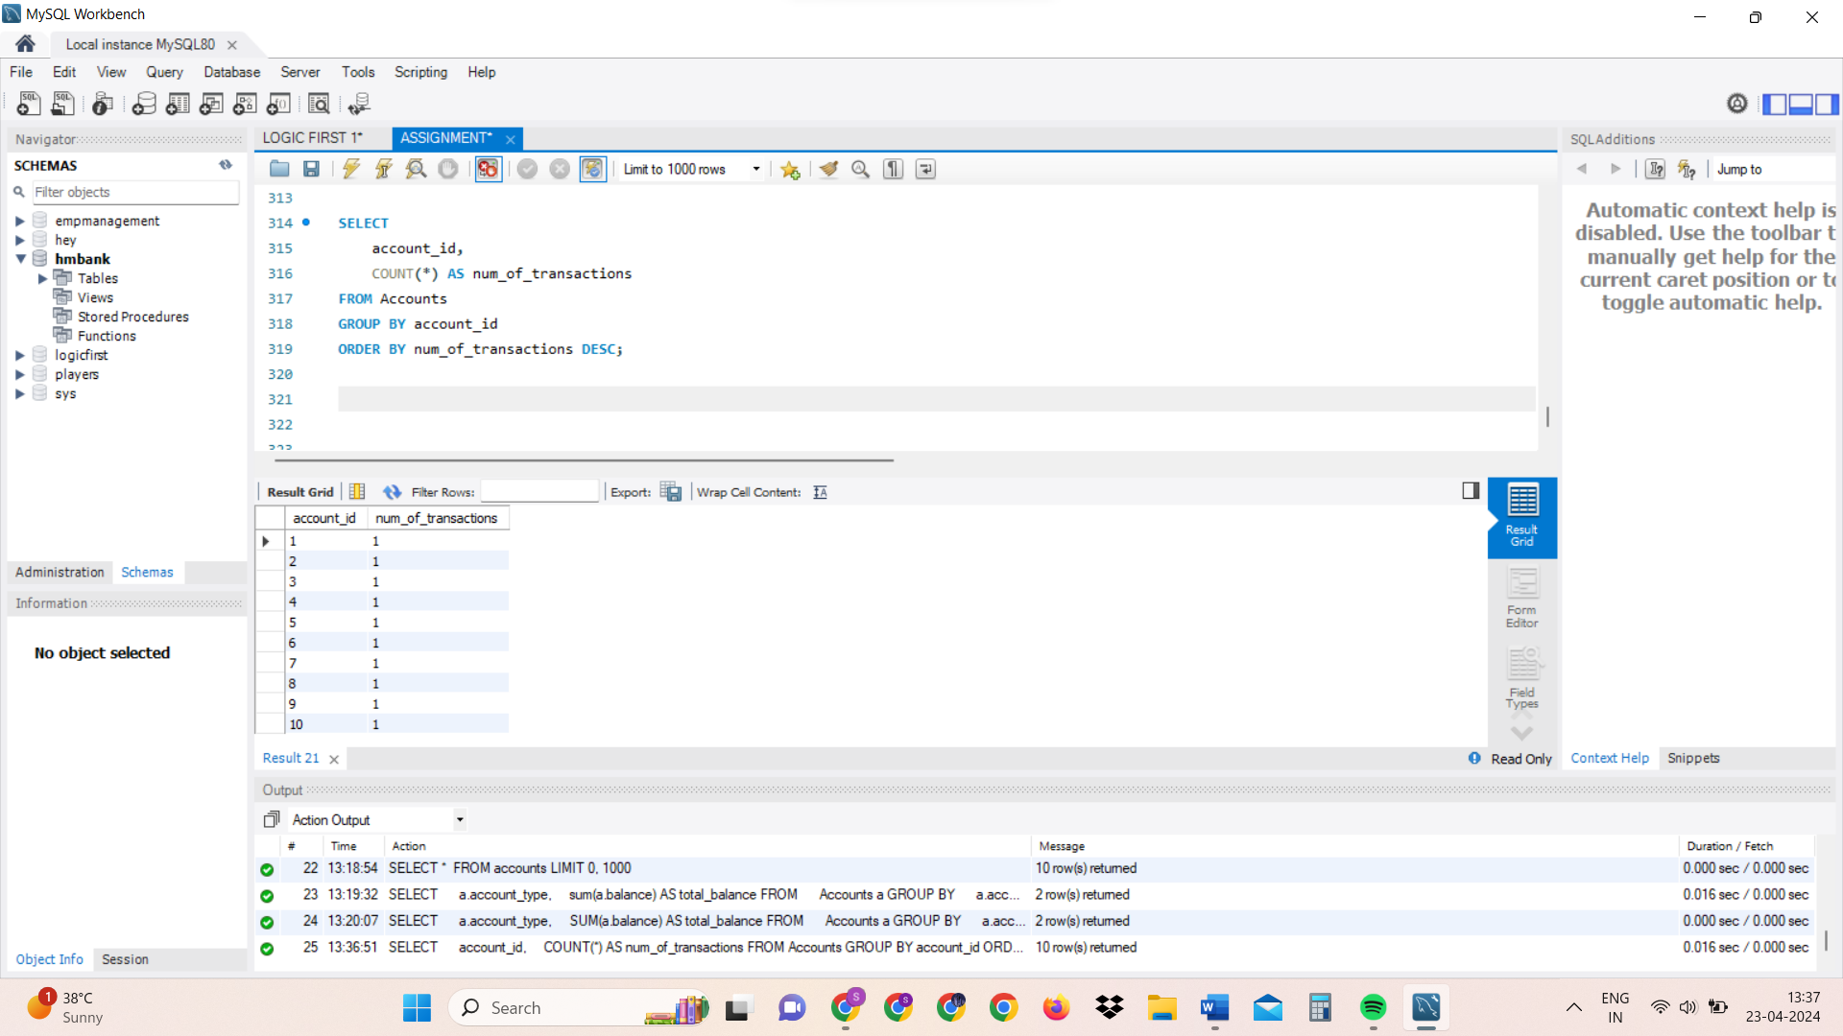

1. List customers with high aggregate account balances, along with their account types.

SELECT

CONCAT (c.first_name, ' ', c.last_name) AS full_name, a.account_type,a.balance

FROM Customers c

INNER JOIN Accounts a ON c. customer_id = a. customer_id

ORDER BY a.balance DESC;

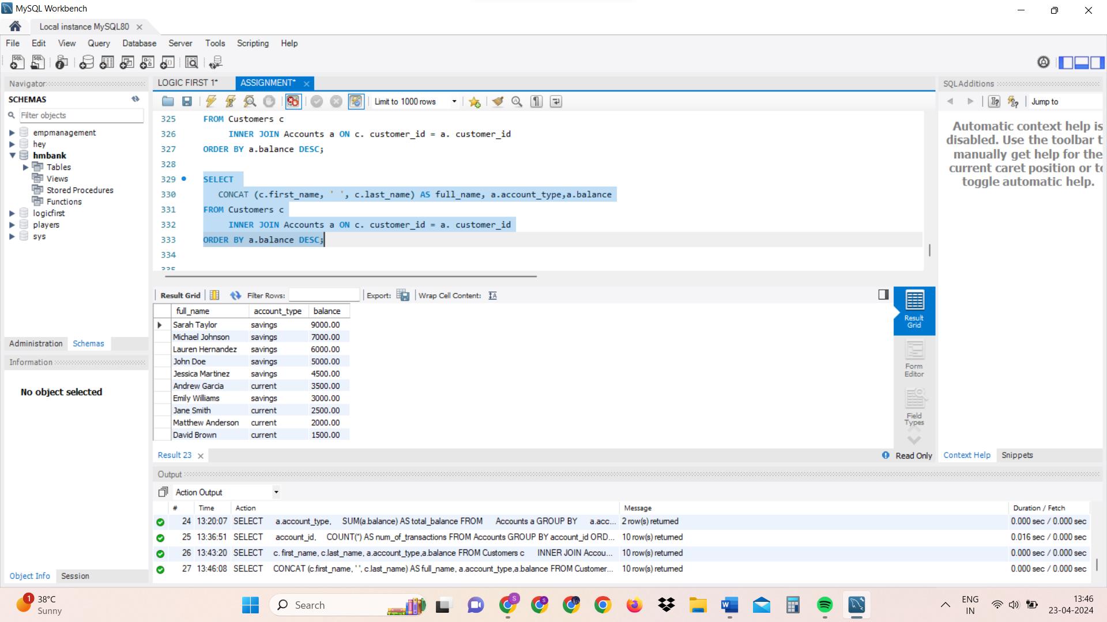

14. Identify and list duplicate transactions based on transaction amount, date, and account.

SELECT

transaction_id,

account_id,

transaction_type,

amount,

transaction_date,

COUNT(*) AS num_of_duplicates

FROM Transactions

GROUP BY transaction_id, account_id, transaction_type, amount, transaction_date

HAVING COUNT(*) > 1;

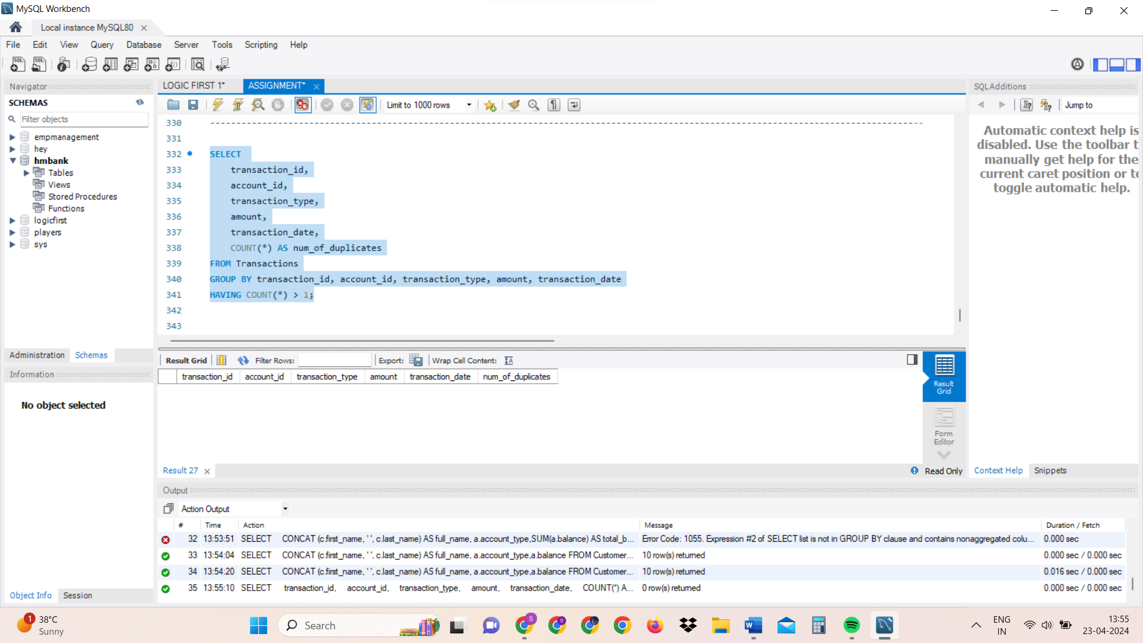

**TASKS 4:**

**Subquery and its type:**

1. Retrieve the customer(s) with the highest account balance.

SELECT

c.customer_id,

c.first_name,

c.last_name,

(SELECT MAX(a.balance) FROM Accounts a WHERE a.customer_id = c.customer_id) AS highest_balance

FROM

Customers c;

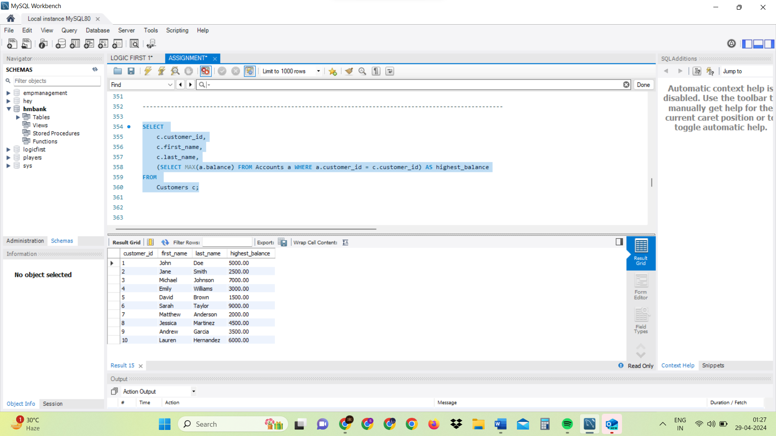

1. Calculate the average account balance for customers who have more than one account.

SELECT

AVG(balance) AS average_balance

FROM

Accounts

WHERE

customer_id IN (SELECT customer_id FROM Accounts GROUP BY customer_id HAVING COUNT(*) > 1);

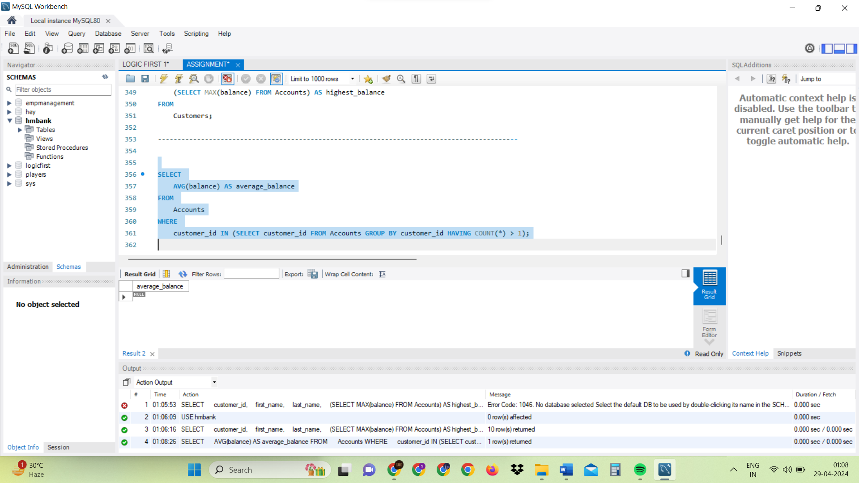

OR

SELECT

AVG(balance) AS average_balance

FROM

Accounts

WHERE

customer_id IN (SELECT customer_id FROM Accounts GROUP BY customer_id);

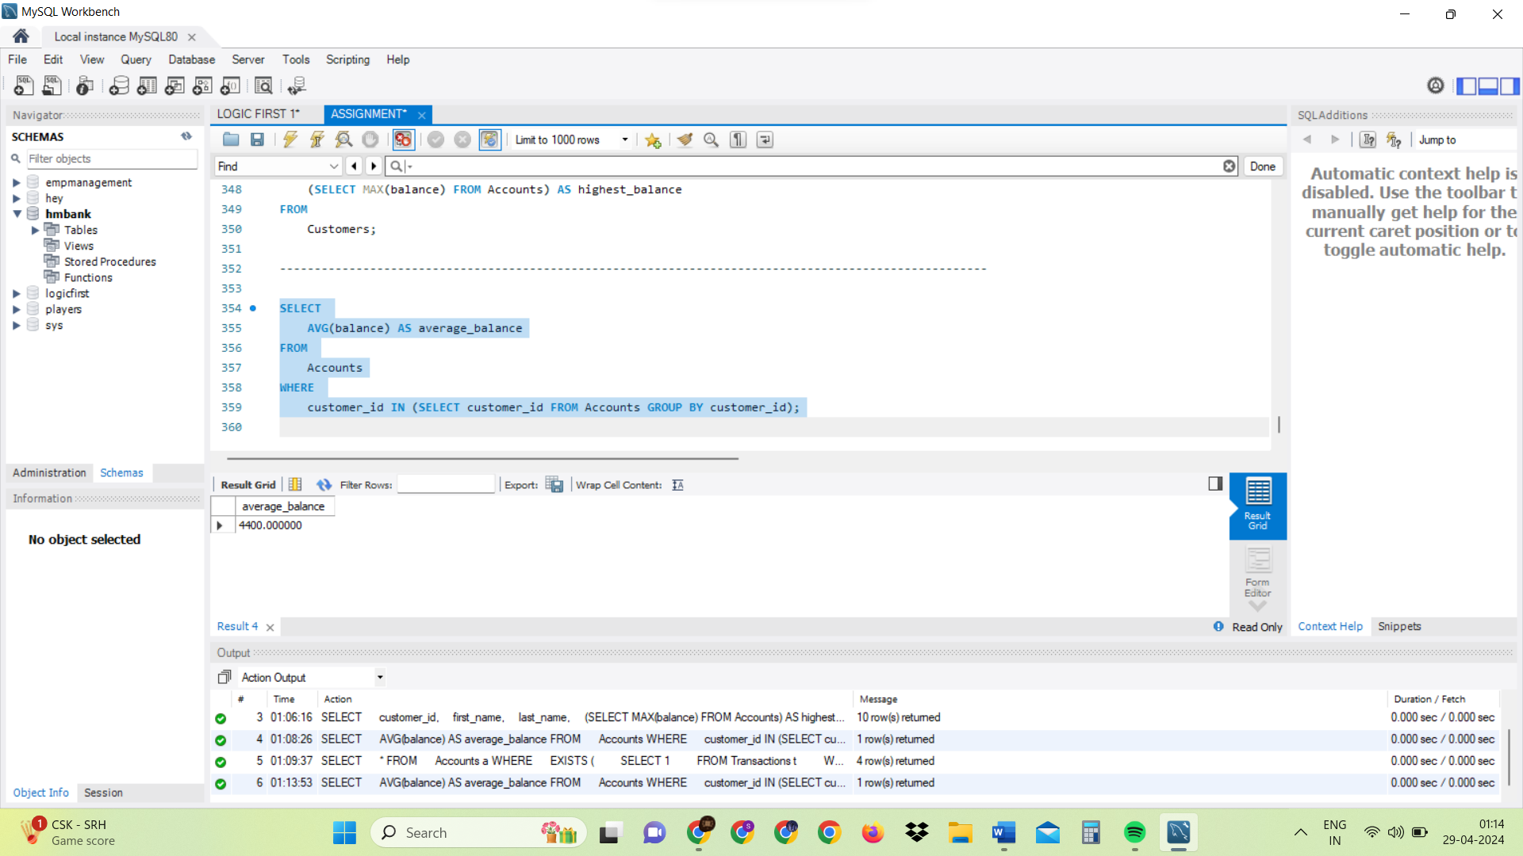

1. Retrieve accounts with transactions whose amounts exceed the average transaction amount.

SELECT

*

FROM

Accounts a

WHERE

EXISTS (

SELECT 1

FROM Transactions t

WHERE t.account_id = a.account_id

GROUP BY t.account_id

HAVING AVG(amount) > (SELECT AVG(amount) FROM Transactions)

);

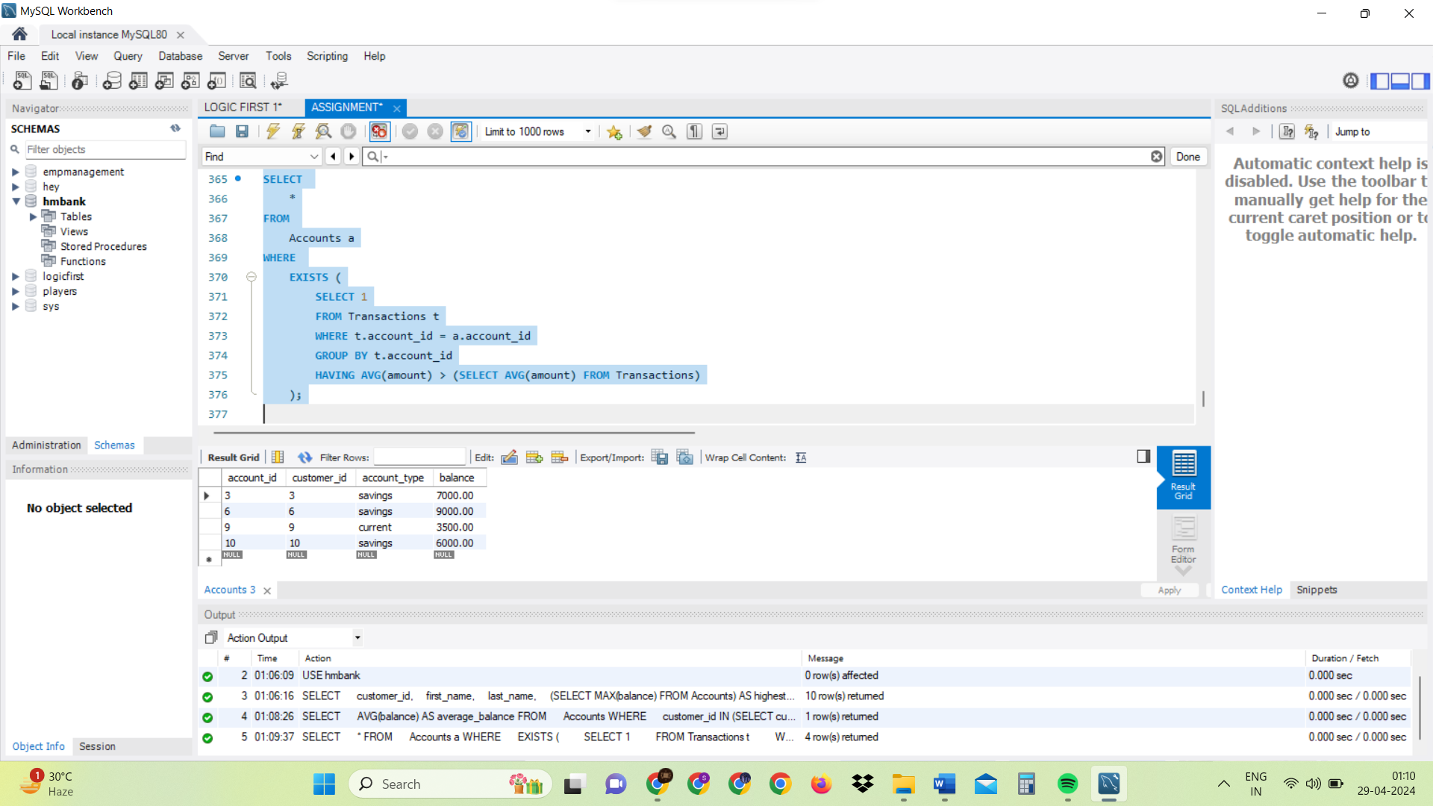

1. Identify customers who have no recorded transactions.

SELECT

*

FROM

Customers c

WHERE

NOT EXISTS (

SELECT 1

FROM Accounts a

WHERE a.customer_id = c.customer_id

);

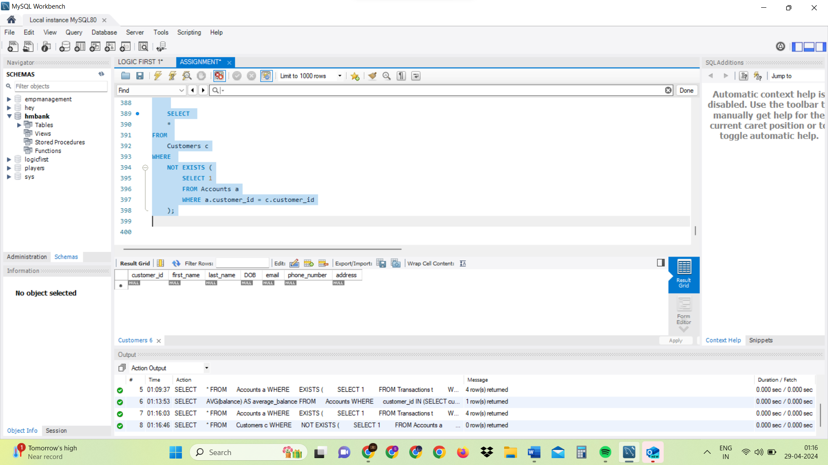

1. Calculate the total balance of accounts with no recorded transactions.

SELECT

SUM(balance) AS total_balance_with_no_transactions

FROM

Accounts

WHERE

NOT EXISTS (

SELECT 1

FROM Transactions t

WHERE t.account_id = Accounts.account_id

);

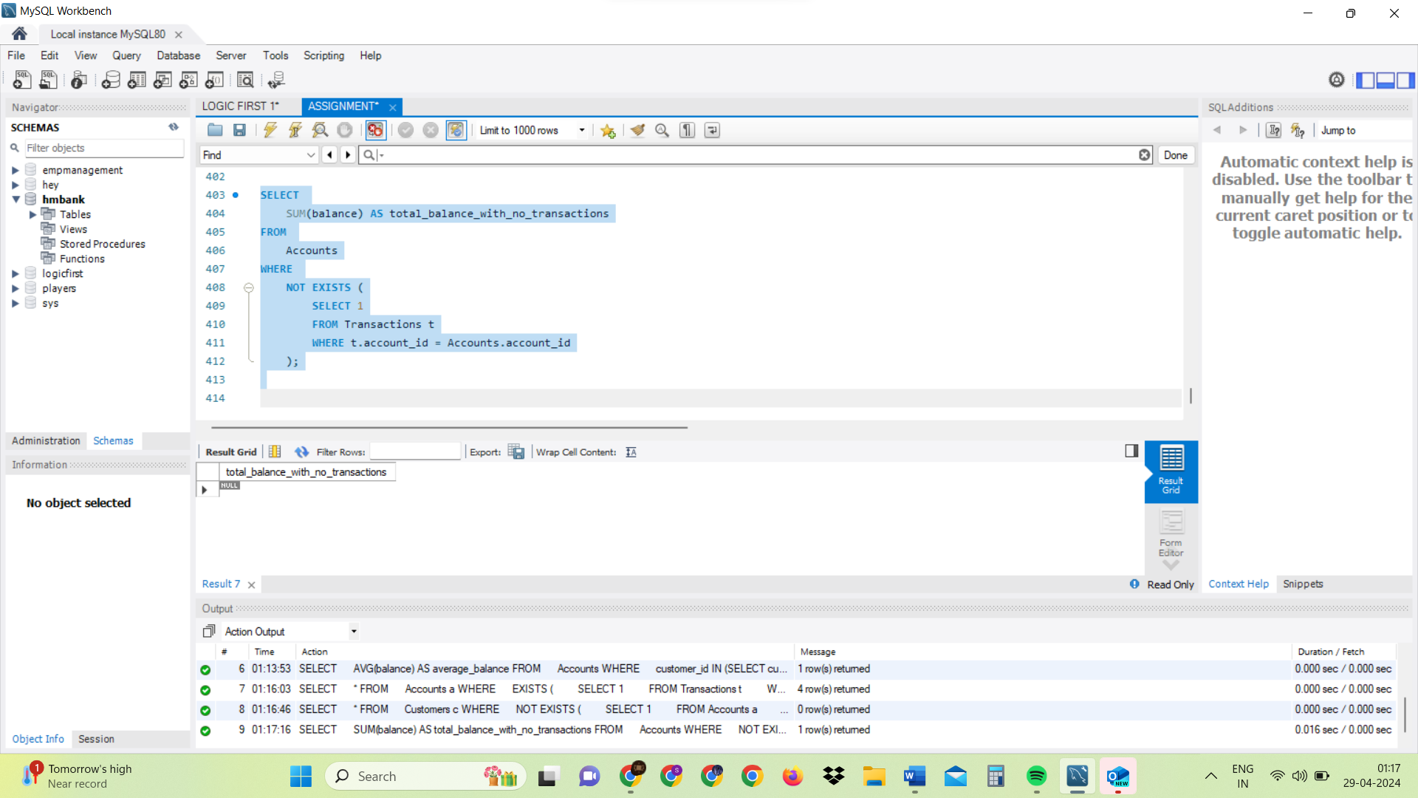

1. Retrieve transactions for accounts with the lowest balance.

SELECT

*

FROM

Transactions t

WHERE

t.account_id IN (

SELECT account_id

FROM Accounts

WHERE balance = (SELECT MIN(balance) FROM Accounts)

);

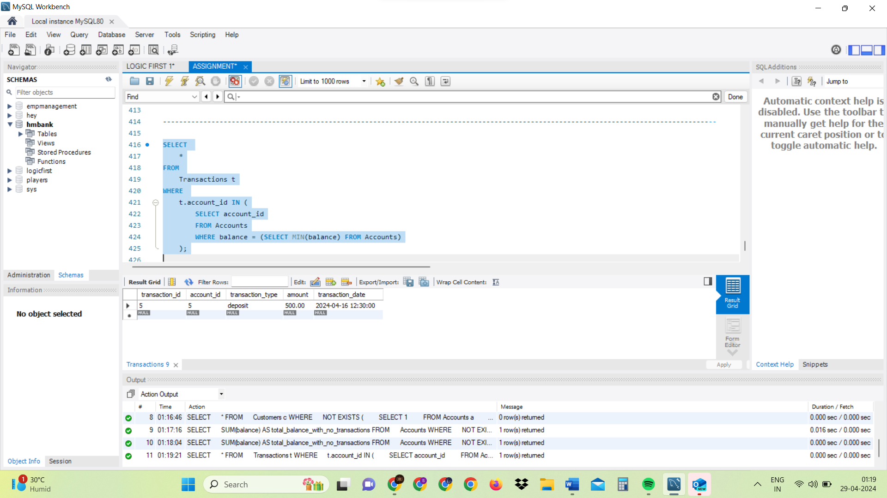

1. Identify customers who have accounts of multiple types.

SELECT

customer_id,

COUNT(DISTINCT account_type) AS num_account_types

FROM

Accounts

GROUP BY

customer_id

HAVING

COUNT(DISTINCT account_type) > 1;

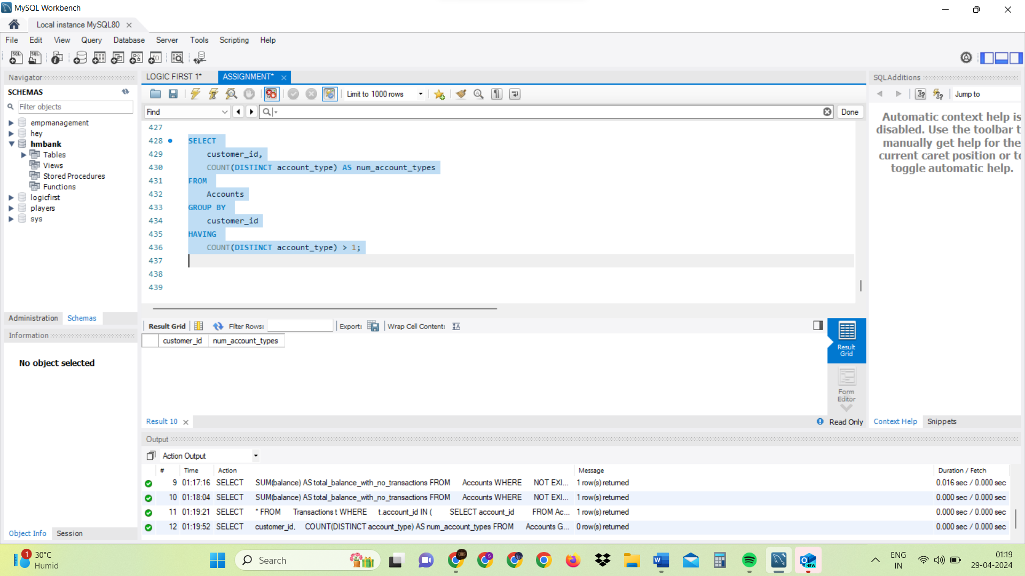

1. Calculate the percentage of each account type out of the total number of accounts.

SELECT

account_type,

COUNT(*) * 100.0 / (SELECT COUNT(*) FROM Accounts) AS percentage

FROM

Accounts

GROUP BY

account_type;

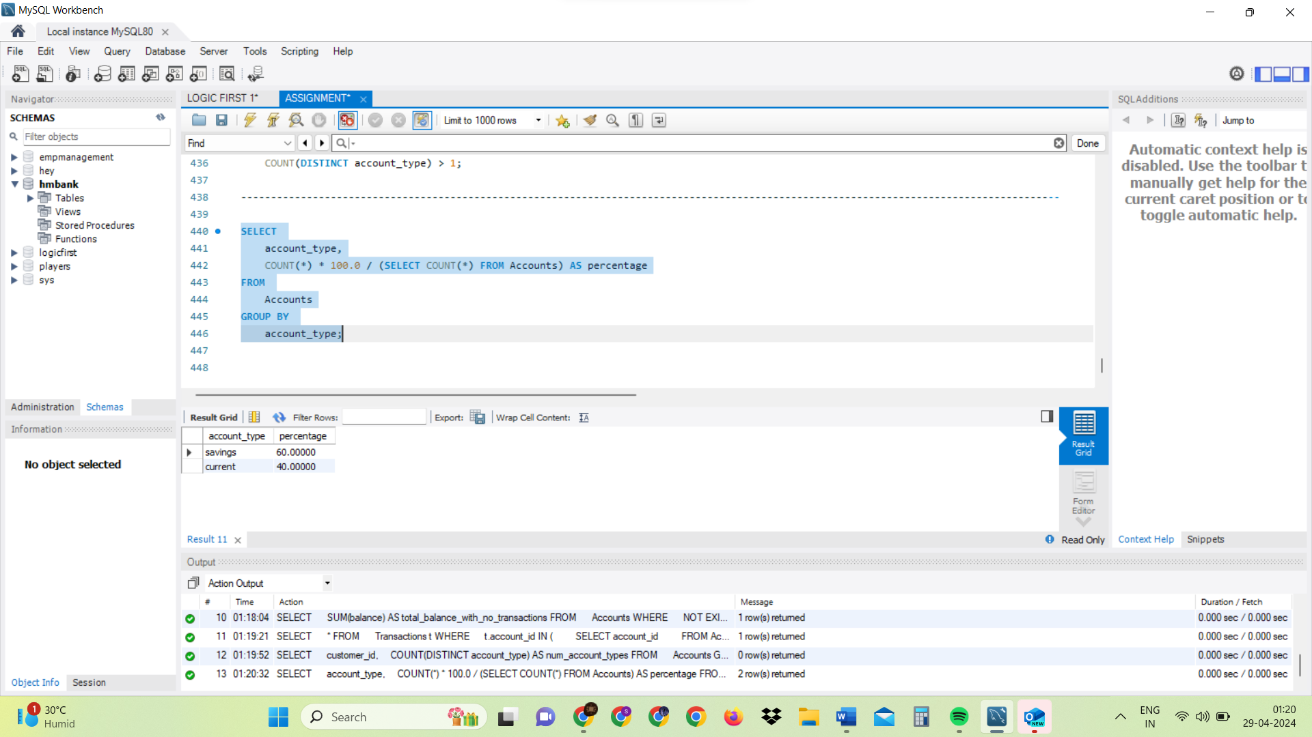

9. Retrieve all transactions for a customer with a given customer_id.

SELECT

*

FROM

Transactions t

WHERE

EXISTS (

SELECT 1

FROM Accounts a

WHERE a.customer_id = 7

AND t.account_id = a.account_id

);

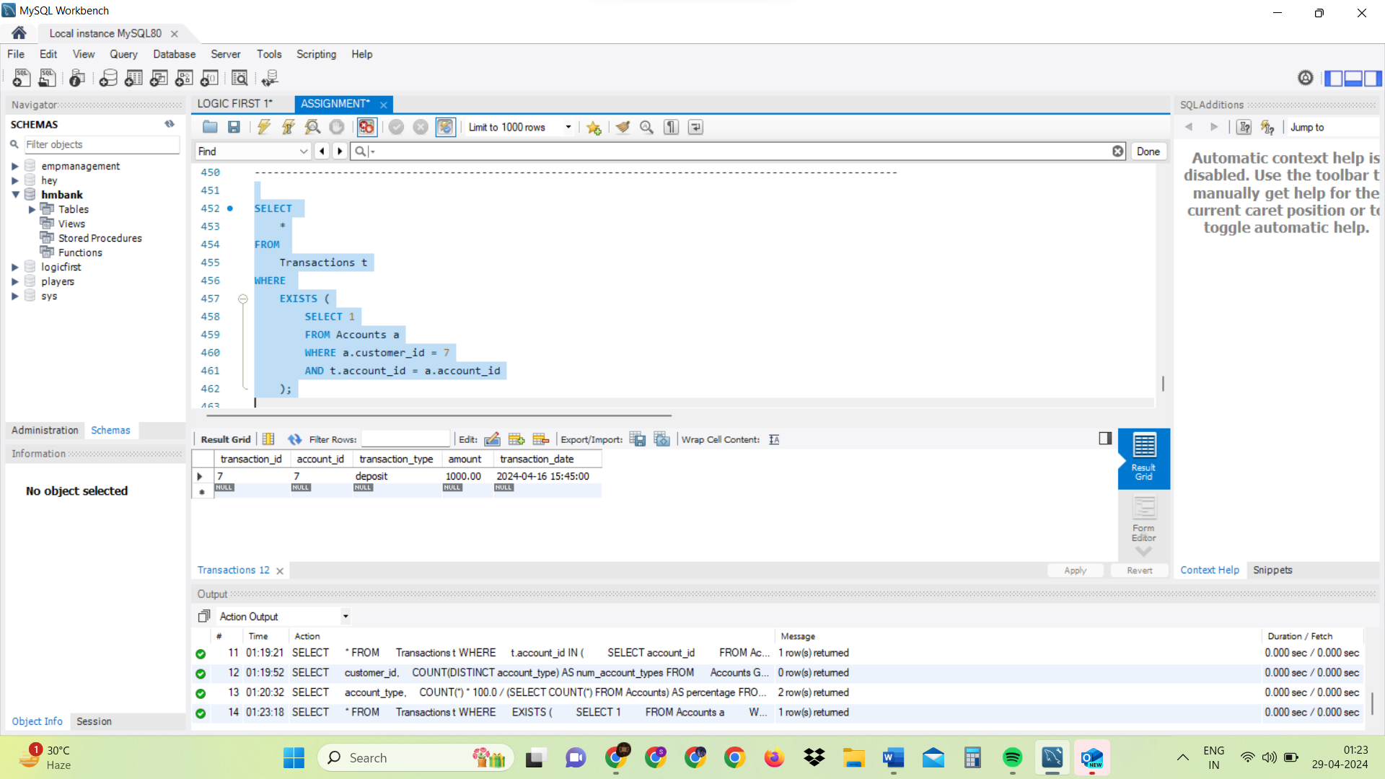

10. Calculate the total balance for each account type, including a subquery within the SELECT

clause.

SELECT

account_type,

(SELECT SUM(balance) FROM Accounts WHERE account_type = a.account_type) AS total_balance

FROM

Accounts a

GROUP BY

account_type;

